ANNEX No. 3 TO THE TENDER DOCUMENTATION

INFORMATION ON THE NECESSARY TECHNICAL, QUALITATIVE AND QUANTITATIVE CHARACTERISTICS OF THE PROCUREMENT ITEM

Scope of work:

Stage 1- design work on the “Construction of area for passenger vehicles and buses in the checkpoint for road traffic “Krakivets” and reconstruction of the infrastructure of the Ukrainian part of the existing checkpoint “Krakivets” on the Ukrainian-Polish border”.

Stage 2 - construction work
- 1 start-up facility “Construction of area for passenger vehicles and buses in the checkpoint for road traffic “Krakivets”;
- 2 start-up facility “Reconstruction of the infrastructure of the Ukrainian part of the existing checkpoint “Krakivets” (two start-up facilities).

Installation of video surveillance (VSS), number-plate recognition (NPRS), access control (ACS), structured cabling (SCN), weighing complexes (including commissioning work), automatic security alarm (ASAS), automatic perimeter security alarm systems (APSAS) is provided for as part of construction work.

STAGE І

Scope statement
for the design of the object “Construction of area for passenger vehicles and buses in the checkpoint for road traffic “Krakivets” and reconstruction of the infrastructure of the Ukrainian part of the existing checkpoint “Krakivets” on the Ukrainian-Polish border”
according to the “design-construction” model
Item No. | List of basic data and requirements | Content of basic data and requirements
1 | Name and location  of construction object | “Construction of area for passenger vehicles and buses in the checkpoint for road traffic “Krakivets” and reconstruction of the infrastructure of the Ukrainian part of the existing checkpoint “Krakivets” on the Ukrainian-Polish border”,  “Krakovets” international automobile crossing checkpoint, situated on international auto route E40 of the ІІІ international transport corridor 54, 55, 56, 57, 58, 59, 60, 61, M. Verbytskogo Str., Krakovets, Krakovets, Yavoriv district, Lviv region
2 | Ground for design | Agreement between the Government of Ukraine and the Government of the Republic of Poland on extending a tied aid credit dd 09.09.2015 was ratified by the Law of Ukraine No. 977-VIII dd 03.02.2016.  Decree of the Cabinet of Ministers of Ukraine dated February 14, 2017 No. 73 "Some issues of the implementation of the Agreement between the Government of Ukraine and the Government of the Republic of Poland on extending tied aid credit"
3 | Type of construction | New construction, reconstruction
4 | Data on investor | (To specify)
5 | Data on customer | The State Customs Service of Ukraine
6 | Source of funding | Credit funds of the Republic of Poland in accordance with the Agreement between the Government of Ukraine and the Government of the Republic of Poland on extending tied aid credit dd 09.09.2015
7 | Necessity of investment efficiency calculations | Investment project for development of border road infrastructure and arrangement of checkpoints (positive conclusion of the Ministry of Finance of Ukraine dated March 28, 2018 No. 12010-04-5/6017)
8 | Data on the general design engineer | To be determined based on the results of the tender.
9 | Stages of design with the determination of the approval stage (determined jointly by the customer and project designer) | Two-stage design: project design (P) (approval stage), detailed design documentation (D).
10 | Engineering survey | Engineering and geodesy surveys - to perform and clarify previously performed ones.  Engineering and geological surveys – to clarify previously performed ones.
11 | Data on special construction conditions (seismic rating, collapsible soil, undermined and flooded areas, etc.) | Seismic rating of 6 points.  The level of restoration, strengthening and reconstruction of load-bearing structures for the service building at the entrance to Ukraine (bus station), transformer substation to be adopted in compliance with clause 11.5 a "restoration of the state of the structures to the pre-damage level" DBN B.1.1-12:2014 "Construction in seismic areas of Ukraine" - "with preservation of the actual level of seismic equipment".
12 | Construction priority, need to identify start-up facilities, features of construction | Two-stage construction.  Stage 1 – 1. Construction of a section for cars and buses at the “Krakovets” international automobile crossing checkpoint; 2. Construction of new treatment facilities and water tower with dismantling of existing ones that have failed; 3. Reconstruction of the transformer substation;  Stage 2 with the allocation of two sturt-up facilities – reconstruction of the infrastructure of the existing "Krakovets" checkpoint in the conditions of its operation.  The first sturt-up facility - 1. Reconstruction of the existing bus station; 2. Are of in-depth inspection; 3. Warehouse of seized and confiscated goods; 4. Diesel-generator room; 5. Sheds (entrance - 3 traffic lanes near the bus station; exit - 3 traffic lanes near the bus station); 6 Passport and customs control pavilions at the entrance and exit - 12 (pcs.); 7. The relevant part of the territory of the checkpoint (landscaping); 8. Checkpoint pavilions (for border guards) - 3 (pcs.); 9. Checkpoint pavilions (for customs officers) - 2 (pcs.)  The second sturt-up facility – 1. Sheds (entrance - 3 traffic lanes; exit - 2 traffic lanes; 2 Passport and customs control pavilions at the entrance and exit - 8 (pcs.); 3. The relevant part of the checkpoint territory (landscaping)
13 | Determination of the class of consequences (responsibility) of the facility and the established period of operation | To be determined while designing.
14 | Project capacity, its composition and main characteristics.  Carrying capacity | The checkpoint operates year-round, 24/7, in two shifts.  Design carrying capacity:  Area for cars and buses (Stage 1)  passengers - up to 8,420 people per day,  3,100 vehicles per day,  including:  - cars - 3,000 cars per day  - buses - 100 buses per day  The number of workers per shift is 69 people per day (2 shifts per day), incl.  - customs officers – 30  - border guards – 35  - other - 4  Area for trucks (Stage 2)  - trucks - 1300 trucks per day  The number of workers per shift is 99 people per day (2 shifts per day)  incl.  - customs officers – 44  - border guards – 20  - other -35
15 | Instructions on the need of  - development of individual technical requirements;  - development of individual design solutions in several variants and on a competitive basis;  - preliminary approvals of project solutions;  - creation of demonstration materials, demonstrators, interior drawings, their composition and form; DBN А.2.2-3:2014 18  - performance of research and pilot testing in the design and construction process, performance of scientific and technical support;  - technical protection of information.  - Performing an examination | - create measurement drawings of the existing border crossing checkpoint infrastructure, inspect the technical condition of buildings and structures and draw up the appropriate act of inspection  - Not required  - The below-mentioned shall be previously agreed with the State Customs Service:  site planes of customs and border units;  technological checkpoint's operation diagram with determination of locations of weighing and scanning equipment;  design considerations in video surveillance (incl. number-plate recognition, access control), automatic security alarm, automatic perimeter security alarm systems and structured cabling)  agreed with the State Customs Service and State Border Service: general layout of the checkpoint  -To be provided by the customer. Appendix 3.5  - Not required  - not required  - Submit design documentation to an expert organization and receive a positive expert report
16 | Basic architectural and planning requirements and characteristics of the construction object | Design areas for cars and buses at the “Krakovets” international automobile crossing checkpoint on the territory of the current “Krakovets” international automobile crossing checkpoint and redesign the existing buildings and structures.  Design for the following as part of the in the first stage:  - 5 traffic lanes for cars and minibuses at the exit;  - 6 traffic lanes for cars and minibuses at the entrance;  - 2 traffic lanes for diplomats;  - 2 traffic lanes for buses at the entrance and exit;  - 2 boxes for in-depth inspection for buses, cars and minibuses (one each at the entrance and exit);  - service buildings for 18 workplaces at the exit;  - public toilets without permanent workplaces at the exit;  - service buildings for 20 workplaces with public toilets at the entrance;  - 1 modular checkpoint pavilion;  - 1 modular checkpoint and checkpoint dispatcher pavilion  - 11 modular customs and passport control pavilions;  - sheds over control zones;  - water tower;  - sewage treatment facilities;  - surface water treatment facilities;  - organized rain water sewer system;  - fire tanks according to calculation;  - fire and security alarm;  - outdoor lighting of the checkpoint territory;  - fencing of territory;  - telephone and computer communication;  - video surveillance system with access control and number-plate recognition systems  - disinfection barrier;  - landscaping;  - road traffic organization;  - container sites for the collection of closed type solid waste;  - site for 25 detained cars.  - Reconstruction of the transformer substation;  Traffic lanes  Traffic lanes for cars and buses should be at least 3.0 m wide and equipped with appropriate signs.  Arrange platforms for removing cars from the general flow on traffic lanes for cars. The platforms shall be located at an angle to the traffic lanes (in the direction of traffic) across the width of the customs and passport control pavilions in the amount of 1(2) platform in front of and behind the pavilions.  Service building at the entrance with public toilets (1 pcs.).  Number of employees - 20  including customs officers - 8  border guards - 10  others - 2  Design the service building as a one-story building with a combined roof. Design the building as a frame one of a steel frame made of rolled profiles. Design the walls of internal wall cassettes insulated with basalt slabs. Design partitions between rooms made of plasterboard, aerated concrete and glazed of aluminum profiles. Design the foundations according to the calculation and engineering and geological surveys. Provide for the ballastless roof with a PVC membrane coating. Provide for insulation of the roof with mineral wool slabs.  Provide for the external decoration of the walls with fiber-cement slabs on internal wall cassettes. Design external windows of metal-plastic profiles with double-glazed windows, stained-glass windows – of aluminum profiles. Design doors to technical premises, as well as evacuation exits in accordance with the requirements of DBN B.1.1-7:2016. Design the entrance/exit doors to the inspection rooms as sliding ones of aluminum profiles. Provide for the arrangement of vestibules of aluminum profiles at the entrances.  Provide for the wall finishing in the inspection rooms with HPL panels. Provide for the wall finishing in service premises with water-emulsion painting, in toilet facilities - facing with ceramic tiles to the entire height of the premises, in technical rooms - with water-emulsion painting.  Design the floors in the offices of industrial linoleum, in the inspection room – of the ceramic granite slabs, in the toilet facilities - of ceramic tiles.  Provide for ceilings in all rooms (except the inspection room) as suspended cassette ones of the Armstrong type, filled with aluminum panels (600X600mm or 1200X600mm). Provide for moisture resistant ceilings in technical rooms and toilet facilities. Provide for suspended rail cube-shaped and island plasterboard ceilings, or a ceiling of the Grigliato type in the inspection room.  Design two passport control cabins in the inspection room as glazed ones of aluminum profiles. Provide for cabins with mirrors for viewing the control area. Provide for one computerized workplace with a computer desk and a chair in each passport control cabin. Provide for turnstiles with remote access control from the cabins on the traffic lanes of people near passport control cabins.  Provide for the installation of two inspection tables for customs control with a stainless steel surface for inspection of hand luggage in the inspection hall.  Provide for the installation of a personal computer with a multifunctional device, a computer table with a chair for each computerized workplace, wardrobe and bookcase in service premises. Provide for a chair, a wardrobe, a table with a chair and a washbasin in the room for personal inspection.  Provide for the following rooms in the building:  - an inspection room for passport and customs control of bus passengers, with the arrangement of two passport control cabins (computerized), one non-computerized customs control workplace and one computerized customs control workplace complete with conveyor type X-ray equipment on the "red" corridor (green and red corridors) (4 persons), arrangement of benches for waiting passengers;  - premise for personal inspection with a washbasin;  - service sanitary and hygienic facilities (toilet facilities):  - sanitary and quarantine station in accordance with the requirements of the current legislation for one computerized workplace (1 person);  - office of the border guard service shift supervisor for two computerized workplaces;  - 2 border guard service premises for two computerized workplaces each;  - premise for placement of technical means for border control of the Gart-1 system, equipped with fire and security alarms, warning system for two computerized workplaces;  - premise (switch room) of the border guard service;  - office of the customs service shift supervisor for two computerized workplaces;  - 2 service premises of the customs service for two computerized workplaces each;  - premises for placement of technical means of customs control;  - premise (switch room) of the customs service;  - premise of the bank for one computerized workplace;  - switchboard room,  - metering station;  - boiler room;  - cleaning facilities premise;  - public toilets.  Provide for air conditioning of the inspection hall, switch rooms and service premises of the customs and border guard services.  Provide for public toilets without a permanent workplace. Provide for the amount of plumbing equipment according to the calculation. Provide for measures to create favourable living conditions for the persons with disabilities in the premises of customs units in accordance with the requirements of DBN B.2.2-40:2018 "Inclusiveness of buildings and structures".  Design public toilets, roof, exterior decoration as in service building. Provide for the interior decoration of the walls of public toilets with ceramic tiles or other cladding materials to the height of the premise up to the suspended ceiling. Provide for suspended ceilings of the Armstrong moisture-resistant type. Provide for the floors of all public toilets of ceramic tiles.  Provide for the following facilities in public toilets:  - vestibule;  - men's toilets with a sluice;  - women's toilets with a sluice;  - mother and child's room;  - universal sanitary and hygienic room for a group of citizens with limited mobility;  - storage room for cleaning facilities.  Service building at the exit (1 pcs.).  Number of employees - 18  including customs officers - 8  border guards - 10  others - 2  Design the service building as a one-story building with a combined roof. Design the building as a frame one of a steel frame made of rolled profiles. Design the walls of internal wall cassettes insulated with basalt slabs. Design partitions between rooms made of plasterboard, aerated concrete and glazed of aluminum profiles. Design the foundations according to the calculation and engineering and geological surveys. Provide for the ballastless roof with a PVC membrane coating. Provide for insulation of the roof with mineral wool slabs.  Provide for the external decoration of the walls with fiber-cement slabs on internal wall cassettes. Design external windows of metal-plastic profiles with double-glazed windows, stained-glass windows – of aluminum profiles. Design doors to service premises of metal-plastic profiles. Design doors to technical premises as well as evacuation exits in accordance with the requirements of DBN B.1.1-7:2016. Design the entrance/exit doors to the inspection rooms as sliding ones of aluminum profiles. Provide for the arrangement of vestibules of aluminum profiles at the entrances.  Provide for the wall finishing in the inspection rooms with HPL panels. Provide for the wall finishing in service premises with water-emulsion painting, in toilet facilities - facing with ceramic tiles to the entire height of the premises, in technical rooms - with water-emulsion painting.  Design the floors in the offices of industrial linoleum, in the inspection room – of the ceramic granite slabs, in the toilet facilities - of ceramic tiles.  Provide for ceilings in all rooms (except the inspection room) as suspended cassette ones of the Armstrong type, filled with aluminum panels (600X600mm or 1200X600mm). Provide for moisture resistant ceilings in technical rooms and toilet facilities. Provide for suspended rail cube-shaped and island plasterboard ceilings, or a ceiling of the Grigliato type in the inspection room.  Design two passport control cabins in the inspection room as glazed ones of aluminum profiles. Provide for cabins with mirrors for viewing the control area. Provide for turnstiles with remote access control from the cabins on the traffic lanes of people near passport control cabins.  Provide for the installation of two inspection tables for customs control with a stainless steel surface for inspection of hand luggage in the inspection room. Provide for one computerized workplace in passport control cabins. Provide for the installation of a personal computer with a multifunctional device, a computer table with a chair for each computerized workplace, wardrobe and bookcase in service premises. Provide for a chair, a wardrobe, a table with a chair and a washbasin in the room for personal inspection.  Provide for the following:  - an inspection hall for passport and customs control of bus passengers, with the arrangement of two passport control cabins (computerized), one non-computerized customs control workplace and one computerized customs control workplace complete with conveyor type X-ray equipment on the "red" corridor (green and red corridors) (4 persons), arrangement of benches for waiting passengers;  - premise for personal inspection with a washbasin;  - service sanitary and hygienic facilities;  - office of the border guard service shift supervisor for two computerized workplaces (2 computerized workplaces);  - 2 border guard service premises (2 computerized workplaces each);  - premise for placement of technical means for border control of the Gart-1 system, equipped with fire and security alarms, warning system (2 computerized workplaces);  - premise of switch room of the border guard service;  - office of the customs service shift supervisor (2 computerized workplaces);  - 2 service premises of the customs service (2 computerized workplaces each);  - premises for placement of technical means of customs control;  - premise of switch room of the customs service  - premise of the bank (1 person);  - medical center premise (1 person);  - boiler room;  - storage room for cleaning facilities.  Provide for air conditioning of the inspection room, switch rooms and service premises of the customs and border guard services.  Provide for the possibility of building a duty-free store on the west side, taking into account the minimum volumes of electricity, water consumption and drainage required for its operation. Design points for connecting the future building of the duty-free shop to engineering networks of water and electricity supply (place in the designed service building with public toilets with the installation of a separate water metering unit, active and reactive electricity metering counter) as well as points for connection to domestic and storm sewer networks.  Public toilets  Provide for public toilets without a permanent workplace.  Provide for the amount of plumbing equipment according to the calculation. Provide for measures to create favourable living conditions for the persons with disabilities in the premises of customs units in accordance with the requirements of DBN B.2.2-40:2018 "Inclusiveness of buildings and structures".  Design public toilets, roof, exterior decoration as in service building. Provide for the interior decoration of the walls of public toilets with ceramic tiles or other cladding materials to the height of the premise up to the suspended ceiling. Provide for suspended ceilings of the Armstrong moisture-resistant type. Provide for the floors of all public toilets of ceramic tiles.  Provide for the following facilities in public toilets:  - vestibule;  - men's toilets with a sluice;  - women's toilets with a sluice;  - mother and child's room;  - universal sanitary and hygienic room for a group of citizens with limited mobility;  - storage room for cleaning facilities.  Sheds over customs and passport control zones  Design sheds over all traffic lanes in the passport and customs control zone.  Design the frame of the sheds of rolled steel profiles. Design the foundations according to the calculation and engineering and geological surveys. Provide for sheds’ covering of corrugated board. Design the cover of the lanterns of monolithic profiled polycarbonate sheets.  Provide for the installation of inspection tables under the sheds for checking the luggage of persons crossing the border in accordance with the number of traffic lanes.  Provide for cladding of steel structures of sheds of aluminum composite sheets on a frame made of aluminum profiles.  Box for in-depth inspection of motor vehicles at the entrance  Number of employees – 2 persons (computerized non-permanent workplaces: one - of the customs service, one - of the border guard service)  Provide the in-depth inspection building for the inspection of buses, minibuses and cars. Design the box building as a one-story building with a combined ballastless roof with PVC membrane coating. Provide for the insulation of the roof with mineral wool plates.  Design the frame building with a steel frame made of rolled profiles. Design the external walls of internal wall cassettes insulated with basalt slabs. Design partitions between rooms made of aerated concrete and plasterboard. Design the foundations according to the calculation and engineering and geological surveys. Provide for the external decoration of the walls with fiber-cement slabs on internal wall cassettes. Design external windows and evacuation exits of metal-plastic profiles with double-glazed windows. Design doors to service premises of metal-plastic profiles. Design steel fire doors with the ANTI-PANIC system in warehouse and technical premises, boxes. Provide for the arrangement of two industrial garage sectional lifting gates for through passage in the box for inspection of buses. Provide for sections of the gates of aluminum profiles, glazed. Provide for the gate with standard heat transfer resistance. Provide for the installation of one garage sectional lifting gate in the box for inspection of minibuses and cars. Provide for the gate sections of aluminum profiles, glazed. Provide for the gate with standard heat transfer resistance. Provide for all gates in the boxes with electric motors. Provide for opening of the gate through access control.  Not provide for internal decoration of external walls of wall cassettes in box rooms. Provide for the finishing of aerated concrete walls in the boxes, in the room of the tire fitting equipment with ceramic tiles to a height of 2 m. Provide for the wall finishing in service premises with water-emulsion painting, in toilet facilities, shower room - facing with ceramic tiles to the entire height of the premises to the suspended ceiling, in a warehouse premise - with water-emulsion painting.  Provide for the floors in the cabinets of industrial linoleum, in the boxes, the room for tire mounting equipment, in the room for temporary storage of confiscated items - concrete floor, in the toilet facilities, shower room, vestibule, boiler room - of ceramic tiles.  Not provide for finishing the ceiling in the premises of boxes, tire fitting equipment, the premises of temporary storage of confiscated items. Provide for suspended cassette ceilings of the Armstrong type in service and auxiliary premises and moisture-resistant ones in technical premises and toilet facilities.  Provide for the installation of two inspection tables for customs officers with a stainless steel surface for inspection of hand luggage and conveyor type X-ray equipment in the boxes. Provide for the installation of tire fitting equipment for buses, minibuses and cars and work tables in the premise of the tire fitting equipment. Provide for the installation of the compressor in a separate room. Provide for the installation of a personal computer with a multifunctional device, a computer table with a chair for each computerized workplace, wardrobe and bookcase in service premises. Provide for the installation of racks for confiscated items in the premises of temporary storage of confiscated items.  Provide for the following premises in the box building:  - box premise for inspecting buses (for one post with an inspection pit in which provide for lighting and ventilation);  - box premise for inspection of minibuses and passenger cars (for one post with an inspection pit in which provide for lighting and ventilation);  - premises for tire mounting equipment;  - premises for temporary storage of confiscated items;  - border guard service personnel premise for one computerized workplace;  - customs service personnel premise for one computerized workplace;  - premises for storing tools of the border guard service;  - premises for storing tools of the customs service;  - boiler room;  - switch room;  - compressor room;  - toilet facilities;  - shower room;  - cleaning facilities premise.  Provide for heating, lighting, ventilation, telephone, computer communication, a video camera for reading vehicle license plates in the box at the entrance, surveillance digital video cameras of the video surveillance system to ensure effective control over the inspection of vehicles.  Box for in-depth inspection of motor vehicles at the exit  Number of employees – 2 persons (computerized non-permanent workplaces: one - of the customs service, one - of the border guard service)  Provide the in-depth inspection building for the inspection of buses, minibuses and cars. Design the box building as a one-story building with a combined ballastless roof with PVC membrane coating. Provide for the insulation of the roof with mineral wool plates.  Provide the in-depth inspection building for the inspection of buses, minibuses and cars. Design the box building as a one-story building with a combined ballastless roof with PVC membrane coating. Provide for the insulation of the roof with mineral wool plates.  Design the frame building with a steel frame made of rolled profiles. Design the external walls of internal wall cassettes insulated with basalt slabs. Design partitions between rooms made of aerated concrete and plasterboard. Design the foundations according to the calculation and engineering and geological surveys. Provide for the external decoration of the walls with fiber-cement slabs on internal wall cassettes. Design external windows and evacuation exits with the ANTI-PANIC system of metal-plastic profiles with double-glazed windows. Design doors to service premises of metal-plastic profiles. Design steel fire doors with the ANTI-PANIC system in warehouse and technical premises, boxes. Provide for the one industrial garage sectional lifting gates in the box. Provide for sections of the gates of aluminum profiles, glazed. Provide for the gate with standard heat transfer resistance. Provide for gates in the box with electric motor. Provide for opening of the gate through access control.  Not provide for internal decoration of external walls of wall cassettes in box rooms. Provide for the finishing of aerated concrete walls in the boxes, in the room of the tire fitting equipment with ceramic tiles to a height of 2 m. Provide for the wall finishing in service premises with water-emulsion painting, in toilet facilities, shower room - facing with ceramic tiles to the entire height of the premises up to the suspended ceiling, in a warehouse premise - with water-emulsion painting.  Provide for the floors in the cabinets of industrial linoleum, in the box, the room for tire mounting equipment, in the room for temporary storage of confiscated items - concrete floor, in the toilet facilities, shower room, vestibule, boiler room - of ceramic tiles.  Not provide for finishing the ceiling in the premises of boxes, tire fitting equipment, compressor room, the premise of temporary storage of confiscated items. Provide for suspended cassette ceilings of the Armstrong type in service and auxiliary premises and moisture-resistant ones in technical premises and toilet facilities.  Provide for the installation of inspection tables for customs officers with a stainless steel surface for inspection of hand luggage and conveyor type X-ray equipment in the boxes. Provide for the installation of tire fitting equipment for buses, minibuses and cars and work tables in the premise of the tire fitting equipment. Provide for the installation of the compressor in a separate room. Provide for the installation of a personal computer with a multifunctional device, a computer table with a chair for each computerized workplace, wardrobe and bookcase in service premises. Provide for the installation of racks for confiscated items in the premises of temporary storage of confiscated items.  Provide for the following premises in the box building:  - box premise for inspecting buses, minibuses and passenger cars (with an inspection pit for inspecting buses);  - premises for tire mounting equipment;  - premises for temporary storage of confiscated items;  - border guard service personnel premise for one computerized workplace;  - customs service personnel premise for one computerized workplace;  - premises for storing tools of the border guard service;  - premises for storing tools of the customs service;  - boiler room;  - switch room;  - compressor room;  - toilet facility;  - shower room;  - cleaning facilities premise.  Provide for heating, lighting, ventilation, telephone, computer communication, a video camera for reading vehicle license plates in the box at the entrance, surveillance digital video cameras of the video surveillance system to ensure effective control over the inspection of vehicles.  Pavilion for passport and customs control  (11 pcs).  The number of employees in each - 2  including customs officers - 1  border guards - 1  Design the pavilion without vestibules with two rooms each with one computerized workplace with separate entrances. Design the pavilion as a frame one of a steel frame made of rolled profiles. Design the walls and roof of sandwich panels with mineral wool filler. Design the foundations according to the calculation and engineering and geological surveys. Provide for the decoration of the walls of the pavilion premises by water-emulsion painting of putty plasterboard sheets on a frame made of galvanized profiles.  Provide for a personal computer with a multifunctional device, a single-desk computer table with a chair in the pavilion premises.  It is necessary to equip with heating, lighting, ventilation, air conditioning, telephone, computer communication, and provide for the customs officials of the State Customs Service who carry out customs clearance, the installation of readers of service cards of the State Customs Service officials with a digital keyboard for controlling the opening of barriers at the exit from the customs control zone (access control system) and installation of a surveillance digital video camera of the video surveillance system in the pavilion.  Provide for a window in the partition for the possibility of transferring documents.  Checkpoint pavilion for one workplace (1 pcs.)  Design the pavilion without vestibules with one room with one computerized workplace. Design the pavilion as a frame one of a steel frame made of rolled profiles. Design the walls and roof of sandwich panels with mineral wool filler. Design the pavilion without a foundation. Provide for the decoration of the walls of the pavilion premises by water-emulsion painting of putty plasterboard sheets on a frame made of galvanized profiles.  Provide for a personal computer with a multifunctional device, a single-desk computer table with a chair in the pavilion premises.  Equip with heating, lighting, ventilation, air conditioning, telephone, computer communication. Provide for the possibility of controlling the opening of barriers at an automated workplace.  Checkpoint and checkpoint dispatcher pavilion (1 pcs.)  The number of employees - 2  including customs officers - 1  border guards - 1  Design the pavilion without vestibules with two rooms each with one computerized workplace with separate entrances. Design the pavilion as a frame one of a steel frame made of rolled profiles. Design the walls and roof of sandwich panels with mineral wool filler. Provide the pavilion without a foundation. Provide for the decoration of the walls of the pavilion premises by water-emulsion painting of putty plasterboard sheets on a frame made of galvanized profiles.  Provide for a personal computer with a multifunctional device, a single-desk computer table with a chair in the pavilion premises.  Equip with heating, lighting, ventilation, air conditioning, telephone, computer communication. Provide for the possibility of controlling the opening of barriers at an automated workplace.  Water tower.  Provide for the replacement of the existing water tower with a new one (capacity according to the calculation) with the installation of water pipes and the installation of automatic equipment (overflow protection).  Fire tanks  Design fire tanks with the calculated volume.  Fire pumping station  Design an underground fire pumping station according to the calculation.  Treatment facilities according to the calculation  Provide for the replacement of existing domestic and rainwater treatment facilities with new ones with a capacity according to the calculation.  Disinfectant barrier  It is located at the entrance to the checkpoint from both sides.  Transformer substation  Provide for:  - complete replacement of electrical equipment;  - internal and external facing;  - replacement of the entrance door.  Diesel room  Provide for:  - internal and external facing;  - replacement of a diesel engine with a more powerful one (with automatic system activation, the power necessary to provide power for the entire checkpoint).  - replacement of the entrance door.  Design construction works as part of two start-up facilities as part of the project design in the second stage:  Design a reconstruction as part of the first start-up facility of the second stage:  - Existing bus station;  - Box of in-depth inspection;  - Warehouse of detained and confiscated items;  - Diesel room;  - Sheds (entrance - 4 traffic lanes near the bus station; exit - 4 traffic lanes near the bus station);  - Passport and customs control pavilions at entrance and exit - 4 (pcs.);  - The relevant part of the checkpoint territory (landscaping);  - Checkpoint pavilions (of border guards and customs officers) - 3 (pcs.);  - Container sites for the collection of closed type solid waste.  Existing building of the bus station  The number of employees - 70  including customs officers – 28 (all computerized workplaces)  border guards – 7 (all computerized workplaces)  others – 35 (16 of them are computerized workplaces)  Provide for:  - reconstruction of the roof with a drainage system;  - renewal of coatings on load-bearing metal structures of the roof (anti-corrosion, fire-resistant, decorative);  - external waterproofing of the foundation and insulation of the basement walls;  - furnishing of facades;  - insulation of facades;  - modernization of the boiler room with replacement of boilers;  - replacement of the heating system;  - replacement of water supply and sewage systems;  - reconstruction of the ventilation system;  - replacement of electrical networks and lighting devices;  - interior equipment of premises;  - full replacement of floors;  - reconstruction of toilet rooms;  - replacement of external carpentry according to new requirements;  - complete replacement of internal doors, complete replacement of external sliding doors;  - provide for the installation of a personal computer with a multifunctional device, a computer table with a chair for each computerized workplace, wardrobe and bookcase in service premises;  - provide for a chair, a wardrobe, a table with a chair and a washbasin in the room for personal inspection;  - provide for the installation of racks in the premises of the archive and warehouses;  - install benches in the waiting areas for drivers;  - provide for the installation of a freight elevator between the first and basement floors;  - reconstruction of the drainage system;  - reconstruction of video surveillance, access control, KTM systems in accordance with the design specification developed with the application of the relevant regulatory documentation adopted in Ukraine;  - gas fire extinguishing of the switch room;  - chemical water treatment;  - reconstruction of the fire alarm system.  Provide air conditioning for server and office premises of customs and border guard services.  Provide measures to create favourable conditions for the life of persons with disabilities.  Provide for the installation of video surveillance cameras.  Box for in-depth inspection  Provide for:  - 2 temporary computerized workplaces of customs officers;  - replacing the roof drainage system;  - replacement of pitched roof covering;  - arrangement of the heating and ventilation system in accordance with the DBN;  - replacement of gates with lifting, sectional, glazed ones, with standard heat transfer resistance, with electric motors, with opening from the access control system;  - interior decoration of the premises;  - reconstruction of motor vehicle maintenance pits;  - replacement of floors;  - insulation and furnishing of facades;  - replacement of windows and doors according to new requirements;  - roof insulation;  - replacement of electrical networks;  - reconstruction of video surveillance and access control systems in accordance with the design specification developed with the application of the relevant regulatory documentation adopted in Ukraine.  - reconstruction of the water supply and drainage network;  - installation of tire mounting equipment for trucks.  Provide for the installation of CCTV cameras  Warehouse of detained and confiscated items.  Provide for:  - one temporary computerized workplace;  - replacement of the roof covering;  - replacement of the floor construction;  - partial replacement of sandwich wall panels;  - reconstruction of the fire water piping;  - installation of racks;  - reconstruction of the fire alarm system.  Provide for the installation of CCTV cameras.  Sheds  Provide for:  - reconstruction, covering of sheds using modern technologies that will ensure energy efficiency;  - replacement of polycarbonate sheets on lanterns;  - replacement of the drainage system from the coating;  - renewal of coatings on the bearing metal structures of sheds and maintenance bridges (anti-corrosion, decorative);  - arrangement of screens from cassettes made of aluminum composite material;  - carry out electrical lighting under the sheds.  Passport and customs control pavilions  Provide for:  - replacement of existing pavilions with the installation of 4 new double pavilions (2 - from the side of exit, 2 - from the side of entrance);  - Provide for computerized workplaces for 8 people (4 customs officers, 4 border guards), heating (electric underfloor heating), lighting, ventilation, air conditioning, telephone and computer communication in the pavilions; provide for the possibility of controlling barriers at the exit from the customs control zone through the access control system and installation of CCTV cameras in the automated workplace of customs officers. Provide a personal computer with a multifunctional device, a single-desk computer table with a chair in the pavilion premises.  Checkpoint pavilion (3 pcs., two of them are double from the side of Ukraine).  Number of employees: border guards – 3, customs officers – 2.  Design the pavilion without vestibules with two rooms each with one computerized workplace with separate entrances. Design the pavilion as a frame one of a steel frame made of rolled profiles. Design the walls and roof of sandwich panels with mineral wool filler. Design the foundation according to the calculation and engineering and geological surveys. Provide for the decoration of the walls of the pavilion premises by water-emulsion painting of putty plasterboard sheets on a frame made of galvanized profiles.  Provide for a personal computer with a multifunctional device, a single-desk computer table with a chair in the pavilion premises, heating (electric underfloor heating), lighting, ventilation, air conditioning, telephone, computer communication; provide for the possibility of controlling barriers at the exit from the checkpoint through the access control system in the automated workplace of border guard officers.  Enclosures for service dogs (instead of existing ones).  Design frame enclosures for six service dogs of steel frame made of rolled profiles.  Determine the foundation by the project design.  Provide for the walls of the enclosures of wooden boards. Design the front wall of the enclosures from bars with the arrangement of gates for entering the enclosures. Provide for the wooden board floor raised above ground level. Provide for a roof made of steel profiled sheets. Provide for the arrangement of wooden dog houses and the installation of 6 metal cabinets for inventory.  Design the following reconstruction as part of the second start-up facility of the second stage:  - Sheds (entrance - 2 traffic lanes; exit - 2 traffic lanes);  - Passport and customs control pavilions for entrance and exit - 2 (pcs.);  - Weighing complex for dynamic weighing of trucks at the entrance with a shed and a pavilion;  - The relevant part of the checkpoint territory (landscaping);  Sheds  Provide for:  - reconstruction, covering of sheds using modern technologies that will ensure energy efficiency;  - replacement of polycarbonate sheets on lanterns;  - replacement of the drainage system from the coating;  - renewal of coatings on the bearing metal structures of sheds and maintenance bridges (anti-corrosion, decorative);  - carry out electrical lighting under the sheds.  Passport and customs control pavilions  Provide for:  - replacement of existing pavilions with the installation of 6 new double pavilions (3 from the side of exit, 3 from the side of entrance);  - Provide for computerized workplaces for 12 people (6 customs officers, 6 border guards), heating (electric underfloor heating), lighting, ventilation, air conditioning, telephone and computer communication in the pavilions; provide for the possibility of controlling barriers at the exit from the customs control zone through the access control system and installation of CCTV cameras in the automated workplace of customs officers. Provide a personal computer with a multifunctional device, a single-desk computer table with a chair in the pavilion premises.  Weighing complex.  Provide for:  - reconstruction of the weighing complex for dynamic weighing of trucks entering Ukraine with the replacement of one non-working scale, repair of the second working scale, and installation of a new third scale to ensure 100 percent weighing of trucks moving to enter Ukraine;  - Reconstruction with extension of the shed of the weighing complex for the third scale;  - reconstruction of the existing weighing pavilion with internal and external furnishing of the premises, installation of air conditioning, installation of 3 customs officers’ workplaces and equip each of them with a single-desk computer table with a chair, as well as install wardrobe and bookcase.
 | Requirements for construction site arranging and landscaping | Stage one:  Provide for:  - design the covering of roads and sites in accordance with the requirements of DBN B.2.3-4-2015 DBN V.2.3-4:2015 "Automotive roads. Transport facilities. Part I. Part II." established for roads of the 3rd category.  - provide for pavements’ and safety islands’ covering under sheds taking into account their cleaning using special grinding technique;  - regulatory slopes of designed roads, platforms, pedestrian sidewalks, taking into account requirements for low-mobility groups of people;  - the width of traffic lanes of all types of vehicles - 3 m;  - arrangement of road asphalt pavement with arrangement of curbs;  - installation of FEM coating under sheds and on sidewalks;  - installation of lights for external electric lighting of the territory;  - arrangement of a fenced site for 25 detained cars. Provide for a sectional fence with a height of min. 1.5 m of welded wire a diameter of 3 mm and cells of 50x200 mm. Provide for gates in the fence that can be opened through access control system;  - arrangement of a site for 5 cars after passport and customs control at the entrance to Ukraine; arrangement of a site for two cars near public toilets in the entrance zone;  - arrangement of a site for three passenger cars for passport and customs control in the exit zone;  - installation of a steel sectional fence of the checkpoint territory with a height of min. 2.2 m of welded wire with diam. of 3 mm and cells of 50x200 mm;  - installation of a steel sectional fence with a height of min. 2.2 m of welded wire with diam. of 3 mm and cells of 50x200 mm;  - installation of a portable turnstile between the "red" and "green" corridors with a height of 0.5 m;  - installation of sliding gates with electric motors with opening through the access control system;  - installation of gates in fences with opening through the access control system;  - installation of gates on the width of traffic lanes at the entrance to the checkpoint from the Ukrainian side;  - installing additional traffic signs, traffic lights and barriers and connecting them to access systems;  - installation of means of forced stopping of cars on all traffic lanes at the entrances and exits to the checkpoint; - installation of certified disinfectant barriers of carpet or irrigation type;  - landscaping of the territory with sown lawns and decorative bushes;  - installation of garbage cans at the entrances to buildings;  - places of installation of information stands in accordance with the requirements of the customs and border guard services;  - location for installation of radiation control racks on the master plan.  The second stage, the first start-up facility:  Provide for:  - reconstruction of road concrete pavement with partial replacement of curbs;  - partial replacement of FEM coatings under sheds and on sidewalks;  - replacement of external electric lighting of the territory;  - replacement of electric lighting cables;  - reconstruction of the rainwater and domestic sewage system;  - installing additional traffic signs, traffic lights and barriers and connecting them to access systems;  - installation of tetrapods at the entrance and exit;  - installation of certified disinfectant barriers of carpet or irrigation type;  - landscaping and planting.  - arrangement of passage to the scanning system for trucks moving out of Ukraine;  The second stage, the second start-up facility:  Provide for:  - asphalting of the parking lot of official passenger cars, adjacent to the transformer and diesel generator room;  - reconstruction of road concrete pavement with partial replacement of curbs;  - partial replacement of FEM coatings under sheds and on sidewalks;  - replacement of external electric lighting of the territory;  - replacement of electric lighting cables;  - revision and partial reconstruction of stormwater treatment facilities;  - separation of traffic lanes (red and green corridor) with turnstiles 0.5 m high;  - repair and painting of the external fence, wickets and gates;  - installing additional traffic signs, traffic lights and barriers and connecting them to access systems;  - landscaping and planting.  Traffic lanes for cars and buses should be at least 3.0 m wide and equipped with appropriate signs.
17 | Requirements for engineering support of the object | The project design provides for the provision of the facility with all the necessary engineering networks in accordance with the technical specifications (TU) and current requirements, norms and rules  When designing, take into account the technical requirements for systems according to the appendices to the technical design specification, which are an integral part of it.  Prove for the installation of weighing complexes, scanning equipment, the creation of a video surveillance system (VSS) with video surveillance subsystems, number-plate recognition (NPRS); access control system (ACS), vehicle weighing and scanning systems (VWSS) in the project. Requirements for special engineering equipment are specified in the appendices to the technical design specification.
18 | Requirements for inclusiveness | Complete the project design taking into account the requirements of DBN B.2.2-40:2018 "Inclusiveness of buildings and structures", regarding ensuring accessibility to buildings and structures and on the territory in accordance with technological requirements for all low-mobility groups of the population, including ones with disorders of the musculoskeletal system, moving in wheelchairs;
19 | Requirements for engineering protection of territories and protection of houses, buildings and structures against dangerous natural or anthropogenic factors | According to the requirements of DBN B.1.1-24:2009 "Protection against dangerous geological processes. Basic provisions of design"  DBN B.1.1-25-2009. "Engineering protection of territories and structures against flooding and flooding" and other norms, standards and rules.  Implement the anthropogenic security section requirements.
20 | Requirements for equipment | Boxes for in-depth inspection of buses, cars and minibuses at the entrance and exit.  Provide for the installation of inspection tables for checking the luggage of persons crossing the border and work tables for the inspection of vehicles in the premises for the inspection of buses, minibuses and passenger cars.  Provide for balancing and on-board machines for buses, minibuses and passenger cars (for the boxes of the section of passenger vehicles), work tables for tools in the premises for tire mounting equipment.  Provide a compressor for tire mounting equipment and pneumatic tools in the compressor room.  Provide for modular storage racks in the warehouse for temporary storage of confiscated items.  Provide a computer desk, wardrobe and bookcases in the office premises of the customs and border guard services.  Provide for a rack for tools in the rooms for storing tools.  Provide for the installation of electronic scales up to 300 kg in boxes of in-depth inspection (one in each of the boxes in the area for passenger vehicles).  Provide for the installation of a conveyor scanning system of a stationary type in accordance with the technical characteristics provided in the technical design specification (Appendix 1);  Service buildings  Provide for the installation of a conveyor scanning system of a stationary type in accordance with the technical characteristics provided in the technical design specification (Appendix 1);  Provide for computer tables with chairs, wardrobe and bookcases in the service premises of the customs and border guard services.  Other  - arrange (on both sides of the checkpoint) stationary means of forced traffic stop, disinfectant barriers in the area of the central entrance gate;  - arrange a protective delimitation of traffic lanes "red and green" corridor (trucks - turnstiles, passenger cars - a fence);  - arrange a metal fence around the perimeter of the checkpoint;  - provide for places for setting up racks for radiological control at the entrances to the checkpoint;  - provide for the installation of traffic lights and barriers at the entrances, exits to the checkpoint and on the traffic lanes;  - provide the checkpoint with a diesel generator with the estimated power required to ensure the operation of the entire checkpoint.
21 | Requirements for the development of the “Environmental impact assessment” section | Develop as part of the project design. Take into account the requirements of the Law of Ukraine "On Environmental Impact Assessment".
22 | Requirements for energy conservation and energy effectiveness | Take into account the requirements of the Law of Ukraine "On Energy Efficiency of Buildings", CMU Decree No. 260 of October 27, 2020 "On Approval of Minimum Requirements for Energy Efficiency of Buildings", DBN B 2.6-31:2016 "Thermal Insulation of Buildings".  According to the requirements of regulatory documentation.
23 | Requirements for the object fire protection systems | According to the requirements of regulatory documentation
24 | Data on technologies and (or) research works proposed by the customer | 60% of materials and equipment must be of Polish origin, but must be certified in Ukraine. Their manufacturer must have a representative office with a service center in Ukraine.
25 | Requirements for the safety and health regime | In accordance with the requirements of the regulatory documentation, taking into account the requirements of the Customs Code and the Law of Ukraine on the State Border and the Resolution of the Cabinet of Ministers of Ukraine dated May 21, 2012 No. 451 "Issues of passage through the state border of persons, road, water, railway, and air vehicles of carriers and goods moved by them.
26 | Requirements for the development of special measures | Provide for Traffic organization project in the project design.  Provide for an autonomous security perimeter alarm system in the project design.
27 | Technical examination | To examine the technical condition of existing buildings, structures and linear facilities of the engineering and transport infrastructure. To carry out dimensional drawings of the existing infrastructure of the checkpoint in a volume sufficient for design in accordance with the requirements of the design specification and the conclusions of examinations of the technical condition of existing buildings, structures and linear facilities of the engineering and transport infrastructure.
28 | Requirements for the creation of demonstration materials,  drawings. | According to DBN A.2.2-3-2014 - two printed copies in Ukrainian, and provide a copy of the project design on an electronic medium; files in PDF format (drawings), DOC (explanatory note) and AVK or similar software complex (estimates).
29 | Requirements for the development of the section of engineering and technical measures of civil protection (civil defense) | According to the requirements of regulatory documentation
30 | Purpose of non-residential floors | International automobile crossing checkpoint (cars, trucks and buses)
31 | List of houses, buildings and structures, linear objects of engineering and transport infrastructure, which are designed as part of the facility | First stage:  - 5 traffic lanes for cars and minibuses at the exit;  - 6 traffic lanes for cars and minibuses at the entrance;  - 2 traffic lanes for diplomats;  - 2 traffic lanes for buses at the entrance and exit;  - 2 boxes for in-depth inspection for buses, cars and minibuses (one each at the entrance and exit);  - service buildings for 18 workplaces at the exit;  - public toilets - at the exit;  - service buildings for 20 workplaces with public toilets at the entrance;  - 2 modular checkpoint pavilions;  - 11 modular customs and passport control pavilions;  - sheds over control zones;  - water tower;  - domestic sewage treatment facilities;  - fire tanks according to calculation;  - fencing of territory;  - disinfection barrier;  - landscaping;  - container sites for the collection of closed type solid waste.  The second stage:  The first start-up facility (reconstruction of):  - Existing bus station;  - Box for in-depth inspection;  - Warehouse of detained and confiscated goods;  - Transformer substation;  - Diesel room;  - Sheds (entrance - 4 traffic lanes near the bus station; exit - 4 traffic lanes near the bus station);  - Passport and customs control pavilions at entrance and exit - 4 (pcs.);  - The relevant part of the checkpoint territory (landscaping);  - Checkpoint pavilions (for border guards and customs officers) - 3 (pcs.);  - Container sites for the collection of closed type solid waste.  The second start-up facility (reconstruction of):  - Sheds (entrance - 6 traffic lanes; exit - 6 traffic lanes);  - Passport and customs control pavilions at entrance and exit - 6 (pcs);  - Weighing complex;  - The relevant part of the checkpoint territory (landscaping);
32 | Requirements for determining the estimated value | Develop the estimated documentation in hryvnias in accordance with the DBN.  Take into account in the estimate documentation funds to cover additional costs associated with inflationary processes and risks.  Provide for additional funds for work in the winter and summer periods.  Not provide for funds for maintenance of the Customer's service and technical supervision.  Include the prices for materials and transportation distances in the estimate documentation after approval by the construction Customer.
33 | Requirements for the number of project copies issued | Provide project documentation: one hard copy form (with original approvals), one e-copy (CD, DVD or USBFlashDrive), and one archival hard copy (kept by the designer).
34 | Certificates, licenses and other permits necessary for the implementation of the project and requirements for their availability | The procedure for licensing business activities related to the creation of architectural objects is determined by the Resolution of the Cabinet of Ministers of Ukraine dated May 23, 2011 No. 554.  The corresponding qualification certificate (license for the development of urban planning documentation; license for architectural and engineering construction design) is issued by the Attestation Architecture and Construction Commission of Ukraine in accordance with the order of the Ministry of Regional Development of Construction and Housing and Communal Services dated 25.06.2011 No. 93 (as amended).  According to Article 20 of the Law of Ukraine of May 20, 1999 No. 687-XIV "On Architectural Activities", foreigners and stateless persons who are in Ukraine on legal grounds enjoy the same rights and bear the same obligations when carrying out architectural activities. as well as citizens of Ukraine, unless otherwise provided by the laws and international treaties of Ukraine, consent to the binding of which has been given by the Verkhovna Rada of Ukraine.  On the territory of Ukraine, foreigners and stateless persons who have not received the appropriate qualification certificate can perform the work specified in Article 19 of this Law and participate in the development of urban planning documentation, design architectural objects, develop working documentation for construction only on the basis of contracts with business entities that have a license to perform certain types of economic activity in construction or with specialists that have a qualification certificate.  According to Article 30 of the Law of Ukraine of May 20, 1999 No. 687-XIV "On Architectural Activity", the author of a project of a work of architecture, urban planning, garden and park art has the exclusive right to make changes to an unfinished or constructed work of architecture in the event of a change in its functional assignment or reconstruction.  The supplier of relevant scanning systems must have:  - license of the State Inspection of Nuclear Regulation of Ukraine for the right to use sources of ionizing radiation (order of SINRU dated August 6, 2012 No. 153);  - permit of the State Sanitary and Epidemiological Service of the Ministry of Health of Ukraine for work with radioactive substances and other sources of ionizing radiation (order of the Ministry of Health of Ukraine dated 02.02.2005 No. 54).  Scanning systems must comply with the radiation safety standards of Ukraine NRBU-97, approved by the order of the Ministry of Health of Ukraine dated 14.07.1997 No. 208, which were put into effect on 01.01.1998 by the Resolution of the Chief State Sanitary Doctor of Ukraine - First Deputy Minister of Health of Ukraine dated 01.12.1997 No. 62  If the participant does not have the above-mentioned permit documents, the participant shall submit a guarantee letter as part of the tender offer with the obligation to obtain all the necessary permit documents in the manner established by law and within the time period provided for in the procurement contract for the performance of relevant works that require the presence of the relevant permit document.

STAGE II
PRELIMINARY TECHNICAL AND ECONOMIC INDICATORS
І START-UP FACILITY OF THE
OBJECT “Construction of area for passenger vehicles and buses in the checkpoint for road traffic “Krakivets” on the Ukrainian-Polish border”.
of the “Krakovets” international automobile crossing checkpoint
54-61, M. Verbytskogo Str., Krakovets, Krakovets, Yavoriv district, Lviv region

Ser.  No. | Name of work | Measurement  units |  | Quantity
1 | 2 | 3 |  | 4
1 | Checkpoint category | - |  | International for automobile crossing
2 | Consequence class | - |  | Clarify CC2 by the calculation according to the project design
3 | Land area | ha |  | 11
4 | Throughput capacity of
 | passengers | persons/day |  | 8420
 | cars | vehicles/day |  | 3100
 | buses | vehicles/day |  | 100
5 | Previous main types and scope of work
 | Arrangement of traffic lanes for cars and minibuses at the exit. | pcs. |  | 5
 | Arrangement of traffic lanes for cars and minibuses at the entrance. | pcs. |  | 6
 | Arrangement of traffic lanes for diplomats at the entrance and exit. | pcs. |  | 2
 | Arrangement of 2 traffic lanes for buses at the entrance and exit. | pcs. |  | 4
 | Construction of service buildings for 20 and 18 workplaces at the entrance and exit | No. |  | 2
 | Construction of sheds over customs and passport control zones | m² |  | Above the traffic lanes
 | Construction of vehicle boxes for in-depth inspection of vehicles. | No. |  | 2
 | Construction of checkpoint pavilions | No. |  | 2
 | Construction of passport and customs control pavilions | No. |  | 11
 | Construction of public toilets | No. |  | Calculation according to the project design
 | Arrangement of a disinfection barrier |  |  | At the entrance
 | Arrangement of sewage treatment facilities |  |  | Calculation according to the project design
 | Reconstruction of rainwater treatment facilities |  | m^{3/}day | according to the project design
 | Replacement of the water tower |  |  | 1
 | Arrangement of fire tanks |  |  | Calculation according to the project design
 | Reconstruction of the transformer substation | m³ |  | 1111,3
 | Furnishing the diesel room, diesel engine replacement |  | kW |  | Calculation according to the project design
 | Telephone and computer communication |  |  | According to the project design
 | Construction of a structured cable system |  |  | According to the project design
 | Arrangement of video surveillance system with number-plate recognition and access control subsystems |  |  | According to the project design
 | Arrangement of fencing and lighting of territories |  |  | According to the project design
 | Landscaping (planting, sidewalks) | pcs. |  | According to the project design
 | Arrangement of fire and security alarm systems |  |  | According to the project design
 | Road traffic organization | ha |  | 11
6 | Provide for the creation of favourable conditions for persons with disabilities in all buildings | - |  | According to the project design
 | - ramps in front of the entrances; | pcs. |  | According to the project design
 | - special toilet room for persons with disabilities. | pcs. |  | According to the project design

PRELIMINARY TECHNICAL AND ECONOMIC INDICATORS
IІ STAGE
FIRT AND SECOND START-UP FACILITIES OF THE
OBJECT “Reconstruction of the infrastructure of the Ukrainian part of the existing checkpoint “Krakivets” on the Ukrainian-Polish border”
Of the “Krakovets” international automobile crossing checkpoint
54-61, M. Verbytskogo Str., Krakovets, Krakovets, Yavoriv district, Lviv region

Ser.  No. | Name of work | Measurement  units | Quantity
1 | 2 | 3 | 4
1 | Checkpoint category | - | International for automobile crossing
2 | Consequence class | - | Clarify ССІІ by the calculation according to the project design
3 | Land area | ha | 11
4 | Throughput capacity of trucks | vehicles/day | 1300
5 | Previous main types and scope of work
 | Reconstruction of the existing bus station | m³ | 19199,4  (approximate h=3,0 m);
 | Reconstruction of the vehicle box for in-depth inspection | m³ | 3000,0
 | Reconstruction of the storage facility for arrested and confiscated goods | m³ | 5711  (approximate h=5,6 м)
 | Reconstruction of the weighing complex with expansion | pcs. | 3
 | Reconstruction of the sheds | m² | 8883,0
 | Replacement of passport and customs control pavilions | pcs. | 10
 | Replacement of the checkpoint and customs dispatcher pavilions | pcs. | 3
 | Finishing of the checkpoint territory, road traffic organization | ha | 11
 | Arrangement of video surveillance system with number-plate recognition and access control subsystems |  | According to the project design
 | Fencing overhaul | lineal metres | 1560,0

TENTATIVE CALENDAR PLAN
Item No. | STAGE | Tentative terms*
І | Development of design and estimate documentation з on the “Construction of the section for cars and buses (1 start-up facility) and restoration (reconstruction) of existing section of truck transport checkpoint (2 stage)” | 2022
 | - development of design and estimate documentation | 12.2022-05.2023
 | - review of design and estimate documentation | 06.2023
 | - approval of design and estimate documentation | 07.2023
ІІ | Construction work | 2023-2024
 | І start-up facility “Construction of a section for cars and buses at the “Krakovets” automobile crossing checkpoint on the Ukrainian-Polish border”
 | Preparatory work | 07.2023 – 08.2023
 | Construction work | 09.2023 – 08.2024
 | Commissioning | 09.2024 – 10.2024
 | Commissioning of the І start-up facility | 11.2024
 | II start-up facility “Reconstruction of infrastructure of Ukrainian part of existing “Krakovets” automobile crossing checkpoint on the Ukrainian-Polish border”
 | First start-up facility
 | Construction work | 12.2024-05.2025
 | Commissioning | 06.2025
 | Commissioning of the І start-up facility | 07.2025
 | Second start-up facility
 | Construction work | 08.2024-11.2025
 | Commissioning | 12.2025
 | Commissioning of the ІI start-up facility | 01.2026
* terms of design and construction work are to be calculated during preparation of design and estimate documentation

Appendix 1 to ANNEX 3

SPECIFICATIONS
of Scanning Equipment

Project “Construction of area for passenger vehicles and buses in the checkpoint for road traffic “Krakivets” and reconstruction of the infrastructure of the Ukrainian part of the existing checkpoint “Krakivets” on the Ukrainian-Polish border”
Address: 54-61, Krakovets, Yavoriv District, Lviv Region

Types of work/expenses | Approximate model | Specifications
Stationary scanning system (conveyor type) (2 pcs) | Rapiscan 624XR (or equivalent) | 1. The stationary scanning system (conveyor type) shall be in the form of a tunnel with a conveyor that uses X-ray radiation to scan luggage and hand luggage moving on the conveyor.  2. The size of the tunnel shall be as follows:  - width – no less than 550 mm;  - height – no less than 850 mm.  3. The generator voltage shall be no less than 140 kV.  4. The generator current shall be no less than 0.7 mA.  5. Availability of a detector matrix.  6. Orientation of the X-ray beam to the item being scanned shall be at an angle of 90º.  7. The conveyor speed shall be no less than 0.20 m/s.  8. The conveyor capacity shall be no less than 165 kg/piece.  9. Penetration through the steel shall be no less than 30 mm.  10. Resolution shall be at least 40 AWG.  11. Availability of computer hardware and specialized software (operator assistance software) for processing and saving scan results. The software shall enable the Customer to process and save scan results, enlarge any part of an image, archive images and separate materials (determine organic and inorganic substances).  12. The maximum dose of X-ray radiation received on the surface of the stationary scanning system shall not exceed 1 μSv/h.  13. The warranty period shall be no less than 24 months.  14. The height of the conveyor of the stationary scanning system from the floor level shall be no more than 325 mm.

Appendix 2 to ANNEX 3

TECHNICAL REQUIREMENTS FOR THE CONSTRUCTION OF vision-based inspection system (VBIS)

The Object: “Construction of area for passenger vehicles and buses in the checkpoint for road traffic “Krakivets” and reconstruction of the infrastructure of the Ukrainian part of the existing checkpoint “Krakivets” on the Ukrainian-Polish border”.
Address: Lviv region, Yavorivskyi district, Krakivets village, Verbytskoho Str., 54-61

 | Specifications
Requirements for technical systems of customs control | 1. General requirements for the Vision-based inspection system  1.1 VBIS is created taking into account the prospects for the development of the State Customs Service and is based on the following principles reflecting the basic requirements for VBIS functioning:  - functioning of VBIS on legal grounds and in accordance with the legislation of Ukraine;  - high-tech and effective VBIS is based on centrally established coordination and management of all its constituent parts and elements. Such coordination is ensured by the presence of a single control center;  - VBIS information will be used both for making operational decisions and for tactical planning based on its analysis;  - readiness of VBIS to display and record in real time violations and current processes simultaneously in all controlled territories;  - application of VBIS intelligent components to ensure resistance to possible violations.  1.2. VBIS is created taking into account the need to receive, process and accumulate information from all infrastructure facilities of customs authorities where customs control and registration are carried out and the adjacent territory necessary to ensure proper customs control.  1.3. VBIS should cover the places of carrying out customs control and goods registration of commercial vehicles crossing the customs border of Ukraine, places where the goods and vehicles under customs control are located and adjacent territory to these places.  1.4. VBIS of the State Customs Service consists of the VBISs of custom houses of the State Customs Service and the monitoring center of the State Customs Service of Ukraine. It is a component of the Unified Automated Information System.  1.5. At the entrance/exit to/from the territory equipped with VBIS, information boards with the inscription “VIDEO MONITORING IN PROGRESS” should be installed.  1.6. VBIS should perform the following functions:  - control over the procedure of movement of goods and commercial vehicles within the controlled territories (checkpoint for road traffic) in real time. Control must be carried out by reading and recognizing license plates of vehicles and trailers/semi-trailers entering/exiting to/from the controlled territory and during the movement of vehicles through the controlled territory, as well as by photo and video recording of vehicles;  - output of video control results to the monitoring center of the State Customs Service of Ukraine.  1.7. VBIS should have the following basic capabilities and functions:  - multi-level password encryption to limit access to video information;  - ensuring the possibility to store video information according to a certain criterion;  - providing the possibility of working with a multi-level interactive map of the territory (country, region, checkpoint for road traffic);  - saving data of the recognized number (date and time of number recognition, its text definition and photo of the number that was recognized, photo of the vehicle);  - provision of video image of the recognized license plate of the vehicle (frame of the moment of the vehicle’s license plate recognition) upon request;  - monitoring the state of VBIS components (video cameras, video servers, weighing systems, scanning systems, etc.) from remote workplaces of the VBIS operators;  - basing on the server platform.  1.8. VBIS should have the following analytical capabilities and functions:  - providing the possibility to analyze events both in real time and by analyzing archival events;  - providing analysis of the vehicle database;  - ensuring the possibility of connecting third-party bases and vehicle data;  - ensuring the possibility of searching through connected databases by the designation of the vehicle number;  - control over the time the vehicle stay at the checkpoint;  - programmed control of the controlled territories;  - visual and audible notification of the VBIS operators about violations of established prohibitions and restrictions in the controlled territories;  - visual and audible notification of the VBIS operators about the presence/absence of queues of vehicles at entrances to the controlled territories;  - preparation of reporting documents;  - management of the license plates database of the recognized vehicle;  - control over the movement of vehicles in the controlled territories (control over the vehicles’ passage through the stages of customs formalities at the control facilities), namely:  • entry into to the territory;  • weighing;  • scanning;  • customs control and registration;  • inspection of vehicles in the boxes of profound inspection;  • control of time spent on the territory;  • departure from the territory, etc.  1.9. Vision-based inspection system must provide integration with the following systems:  - vehicle license plate reading system;  - access control and management system;  - vehicle weighing system;  - scanning systems;  - other systems (if necessary).  2. System software requirements  2.1. The VBIS software must provide:  - control over the movement of vehicles within the controlled territories (checkpoint for road traffic in real time. Control should be carried out by reading and recognizing license plates of vehicles and trailers/semi-trailers when entering/exiting to/from the controlled territory and when moving vehicles in the controlled territory, as well as by photo and video recording of vehicles;  - output of video control results to the monitoring center of the State Customs Service of Ukraine;  - working with a multi-level interactive map of the controlled territory (at least three levels - country, region, controlled territory);  - monitoring of the state of components of Vision-based inspection system (video cameras, video servers, weighing systems, scanning systems, controllers, etc.) from remote workplaces of the VBIS operators;  - basing on the server platform;  - possibility to display simultaneously images from several cameras, as well as full-screen display of video information from each video camera;  - possibility of assigning a text mark to each video camera; inscription must include the number and name of the video camera, current time and date;  - possibility of exporting video information to external media;  - possibility of individual adjustment of image parameters, quality of the compressed image, recording speed for each camera;  - possibility to set recording modes: in the presence of movement, external alarm signal, continuous recording, scheduled recording, cyclic recording;  - possibility to set the recording storage time on the server independently for each camera;  - possibility of analyzing events both in real time and by analyzing archival events;  - provision of vehicle database analysis;  - control over the time of the vehicle's stay in the controlled territory;  - visual and audible notification of the VBIS operator about violations of the established prohibitions and restrictions in the controlled territories;  - visual and audible notification of the VBIS operator about the vehicle found in the connected search databases;  - visual and audible notification of the VBIS operator about the presence/absence of queues of vehicles at the entrances to checkpoints for road traffic;  - creation of reporting documentation (by checkpoints, regional customs, violations of the stages of customs formalities during customs control, by time, by country of vehicle registration, etc.) in pdf format files;  - control over the movement of vehicles in the controlled territories (control over the vehicle’s passage through the stages of customs formalities at the checkpoint for road traffic), namely:  a) entry to the checkpoint;  b) weighing;  c) scanning;  d) customs control and customs clearance;  e) inspection of the vehicle in the boxes of profound inspection (if necessary);  e) exit from the checkpoint, etc.  Backup and restoration of the system at the of level a checkpoint for road traffic and monitoring center of the State Customs Service of Ukraine;  - availability of central part (core) of the system at the level of car checkpoint and coordination and monitoring customs of the State Customs Service with the possibility to process up to 100 objects (car checkpoints);  - maintaining archive of events;  - formation of a database with data received from the integrated systems for each vehicle, namely:  • date and time of the vehicle entry to the car checkpoint;  • the name of the car checkpoint and customs house of the State Customs Service;  • photo of the vehicle cabin with a license plate;  • photo of the vehicle's front license plate;  • photo of the trailer/semi-trailer or the vehicle's rear part with a license plate;  • photo of the vehicle's rear license plate;  • recognized (in the text form) front and rear vehicle license plates;  • country of the vehicle registration;  • vehicle weight in tons or kilograms;  • unique number of the weighing complex on which the vehicle was weighed;  • recognized (in the text form) front vehicle license plate on the weighing complex;  • image of the vehicle processed by SS (scanning system) operator and inspected using the scanning system;  • unique SS number, which was used for vehicle inspection;  • recognized (in text form) front license plate of the vehicle at the exit from the scanning system;  • vehicle traffic lane (“red corridor”, “green corridor” for buses, neutral (diplomatic));  • the number service certificate of the customs official of the State Customs Service who carried out registration of the vehicle;  • the number service certificate of the customs official of the State Customs Service in case the bascule barrier is opened manually;  • date and time of vehicle departure from the territory of the car checkpoint;  • recognized (in the text form) front and rear license plates of the vehicle at the exit from the car checkpoint territory;  • direction of movement (to Ukraine, from Ukraine);  • vehicle stay time at the car checkpoint.  Carrying out analysis of the vehicle passage through all stages of customs formalities at checkpoints for road traffic and, in accordance with the results of the analysis, allowing or prohibiting the vehicle from leaving the customs control zone using software control of the bascule barriers;  - drawing up a protocol for the VBIS operator for prompt response to alarms received from video control systems installed in the car checkpoint and the possibility of their printing;  - carrying out a search in the created VBIS database according to the specified criteria;  - possibility of exporting data from the VBIS database to *.xlsx (*.xls), *.pdf format files.  2.2. VBIS software must meet the following requirements:  - provision of technical support for functionality of the software during the warranty period;  - free provision of new versions of the software should be carried out as they are released to ensure full functionality of the software during the warranty period;  - installation of the software using the installation MSI file/exe file.  - configuration and further administration of the system should be carried out from a centralized place of the administrator;  - possibility to create and store reports on software errors;  - support for several categories of users (for example: administrator, safety officer, operator, etc.);  - availability of multi-level password protection to limit access to video information;  - presence of restrictions for user access to software settings with the possibility of entering a password of up to 16 characters;  - availability of user account control support.  The software should provide possibility to receive and process information from the following systems:  a) reading vehicles’ license plates;  b) access control and management;  c) vehicles’ weighing;  d) scanning systems;  e) other systems (if necessary);  Availability of both individual and group settings of users or objects;  - availability of a localized interface (in Ukrainian and/or in Russian) and documentation (in Ukrainian);  - the software must ensure operation of the server equipment under the management of MS Windows operating systems;  - support for all common types of databases, namely: DBASE, MS ACCESS, MS SQL Server, MySQL, PostgreSQL, ORACLE;  - compatibility with antivirus protection systems.  2.3. Requirements for VBIS software interface  The interface should be in the form of a multi-level interactive map (country, region, car checkpoint (controlled territory)), on which alarms should be displayed for the VBIS operator formed according to the specified parameters in the car checkpoints with the installed VBIS; and if they are present, they should be displayed by a red circle and digital value of the number of violations in the circle, and in case of their absence - by a green circle on the map of Ukraine at the places of car checkpoints locations.  A map of Ukraine should be displayed on the first level divided into zones of activity of the State Customs Service with car checkpoints in the form of circles.  In order to view the events in detail, by clicking on the relevant region on the map (area of ​​activity of the customs house of the State Customs Service) the second level of the interactive map should open with the locations of the corresponding car checkpoints in the form of a circle, and when clicking on the corresponding car checkpoint (circle) on the map the third level of the interactive map should open on which the controlled territory should be displayed, that is, the car checkpoint scheme and the equipment of the systems installed in the car checkpoint (video cameras, weight complexes, scanning systems, etc.)  At the third level, the VBIS operator must have the possibility to view video images of each of the installed video cameras in real time, as well as view the video archive behind them, and the possibility to work with the VBIS database in the form of a table, which should contain the following data:  - date and time of vehicle entry to the car checkpoint;  - car checkpoint name and customs house of the State Customs Service;  - photo of the vehicle cabin with a license plate;  - photo of the vehicle's front license plate;  - photo of the trailer/semi-trailer or rear part of the vehicle with a license plate;  - photo of the vehicle's rear license plate;  - recognized (in the text form) front and rear vehicle license plates;  - country of the vehicle registration;  - vehicle weight in tons or kilograms;  - unique number of the weighing complex on which the vehicle was weighed;  - recognized (in the text form) front number plate of the vehicle on the weighing complex;  - vehicle image processed by the SS operator and inspected using the scanning system;  - unique number of the SS, which was used for vehicle inspection;  - recognized (in the text form) front license plate of the vehicle at the exit from the scanning system;  - traffic lane of the vehicle (“red corridor”, “green corridor”, for buses, neutral (diplomatic));  - the number of service certificate of the customs official of the State Customs Service who carried out registration of the vehicle;  - the number service certificate of the customs official of the State Customs Service in case the bascule barrier is opened manually;  - date and time of vehicle departure from the territory of the car checkpoint;  - recognized (in the text form) front and rear license plates of the vehicle at the exit from the car checkpoint territory;  - direction of movement (to Ukraine, from Ukraine);  - vehicle stay time at the car checkpoint.  Also, the VBIS operator should have the possibility to access and display information about the following events at the car checkpoint:  - the presence or absence of a queue at the entrances to the car checkpoint from the side of Ukraine and from the neighboring country;  - operational efficiency of the equipment of VBIS components (video cameras, servers, network storage);  - in the absence of information in the data table about the stages of customs formalities at a car checkpoint, such as weighing and scanning, this should be displayed in the table in red;  - information about the vehicle found in the search databases (in the form of a visual and audio message with a photo of the found vehicle and information about the relevant database);  - possibility of creating and viewing databases of vehicles found in search databases and the possibility of searching them by vehicle number;  - visual and audible notification of the VBIS operator about vehicles that have been moved more than once in the last 24 hours (analysis should be carried out only in the case of movement from the territory of a neighboring state to the territory of Ukraine);  - visual and audible notification of the VBIS operator of the vehicle’s passage through the gate in order to turn around at the checkpoint;  - visual and audible notification of the VBIS operator of the vehicle’s entry to the profound inspection box.  It is necessary to provide for the possibility of installing the VBIS software at the workplaces of customs officials of the State Customs Service who carry out customs clearance at car checkpoints, ensuring:  - visual and audio notification (with a photo of the found vehicle) about the vehicle found in the search databases;  - visual and audio notification (with a photo of the found vehicle) about the vehicle that has been moved more than once in the last 24 hours (the analysis should be carried out only in the case of movement from the territory of a neighboring state to the territory of Ukraine);  - a real-time video image of the vehicle in front of the bascule barrier at the exit from the customs control area at the stage of customs clearance, namely: video image of the vehicle cabin with the vehicle’s license plate, which must be clearly legible visually.  2.4. Minimum requirements for VBIS equipment:  Minimum requirements for server equipment (not worse):  - processor Intel® Xeon E5-1620 v4 4x3.5GHz, 10MB Cache, 140W, LGA2011-3);  - RAM DDR3 16 GB;  - HDD volume at least 10 TB (RAID 5);  - graphic adapter 1 GB;  - network interface of at least 1 Gb Ethernet (at least 2 pcs);  - RAID controller;  - power supply unit 550 W with the possibility of hot replacement (at least 2 pcs.).  Minimum requirements for digital cameras (not worse):  - day/night operation mode;  - maximum resolution - not less than 1080 p;  - recording - up to 30 fps (frames per second) for 1080 p resolution;  - real wide dynamic range of at least 100 dB;  - signal/noise ratio - not less than 50 dB;  - electronic shutter range - not less than 1/2000 s;  - automatic focusing adjustment;  - image “blurring” compensation;  - sensitivity: color mode - 0.10 lux, monochrome mode - 0.05 lux;  - video signal encoding: H.265, H.264 with high, basic or main profile and MJPEG;  - at least two simultaneous video streams;  - availability of mechanical infrared rejection filter;  - PoE power supply (IEEE 802.3af);  - compliance with ONVIF Profile S, T;  - availability of analytical function - tampering (antisabotage);  - warranty period of at least 36 months.  2.5. The license plate reader (LPR) software shall provide:  - monitoring the vehicles within monitored areas in real time;  - availability of analytical functions - movement detection, line crossing, glass detector (for tracing the driver), monitoring the movement of a vehicle in the monitored areas more than once in the last 24 hours, monitoring the time of stay in the monitored area;  - data transmission to data storage and archiving servers;  - reading and recognition of all types of license plates of Ukrainian vehicles, including two-line ones (according to DSTU 4278:2012) and all types of license plates of European and CIS countries;  - reading and recognition of license plates of vehicles in the speed range from 2 to 80 km/h.  - the probability of recognition shall be at least 95 percent; provided that the license plate conforms to the requirements of the Vienna Convention on Road Traffic of 8 November 1968;  - transmission of vehicle license plate reading data, as well as license plate photos and vehicle photos and videos to data storage and archiving servers;  - support of digital video cameras of all manufacturers - use of Onvif or RTSP protocols (without password and login);  - support of all common types of databases, namely: DBASE, MS ACCESS, MS SQL Server, MySQL, PostgreSQL, ORACLE;  - operation with external databases (for the purposes of automatic search of vehicles based on license plates);  - support for creating separate database logs (for example, "Entry", "Weighing", "Exit", "Company vehicles", etc.);  - support for operation with operational units (barriers, traffic lights, etc.);  - support for exporting data to third party software products;  - saving in its own database the information about the date/time of registration of the vehicle license plate, recognized front/rear vehicle license plates in text form, photos of front/rear vehicle license plates, front/rear photos of the vehicle, country of vehicle registration;  - work with the database of information about the date/time of registration of the vehicle license plate, recognized front/rear vehicle license plates in text form, photos of front/rear vehicle license plates, front/rear photos of the vehicle, country of vehicle registration;  - the number of client connections supported by the license shall be at least 10;  The software shall conform to the following requirements:  - provision of technical support for the functionality of the software during the warranty period;  - new versions of the software shall be provided freely as they are released, to ensure the full functionality of the software during the warranty period;  - the software shall be installed using the M8I installation file/exe file;  - set-up and further administration of the system shall be carried out from a centralized place of the administrator;  - the option of reinstalling the license plate reading system software without losing settings;  - the option of generating and storing reports on software errors;  - availability of security policies and their management;  - the option of export/import and distribution of the configuration, downloading of the configuration file with connection settings;  - processing of at least 6 video channels of recognition;  - availability of both individual and group settings of users or objects;  - availability of a localized interface (Ukrainian and/or Russian language(s)) and documentation (Ukrainian language);  - the option of setting up and updating the database of vehicle license plate templates;  - consider that the estimated distance to the recognition area is from 5 to 27 meters;  - consider that the video camera suspension height is from 2 to 11 meters;  - consider that the width of the monitored area is from 3 to 4 meters;  - consider that the tilt angle of the video camera shall not exceed 30° vertically and horizontally;  - operation of the server equipment under the management of MS Windows operating systems;  - compatibility with antivirus protection systems;  - support of a secure VPN network or a local network without access to the Internet;  - support of encryption of data stored in the database.  2.6. Minimum requirements for the LPR equipment (at least):  Minimum requirements for the server equipment (at least):  - Intel® Xeon E5-1620 v4 processor (4x3.5GHz, 10MB Cache, 140W, LGA2011-3);  - random access memory (RAM) DDR3 16 GB;  - HDD capacity of at least 8 TB (RAID 5);  - graphic adapter 1 GB;  - network interface of at least 1 Gb Ethernet (at least 2 pcs);  - RAID controller;  - power supply unit 550 W with the hot swapping option (at least 2 pcs).  Minimum requirements for the digital video cameras (at least):  - day/night operation mode;  - maximum resolution: at least 1080p;  - recording up to 30 fps (frames per second) for a resolution of 1080p;  - real wide dynamic range: at least 100 dB;  - signal/noise ratio: at least 50 dB;  - electronic shutter range: at least 1/5000 s;  - automatic focusing adjustment;  - image "blurring" compensation;  - sensitivity: colour mode - 0.10 lux, monochrome mode - 0.05 lux;  - video signal coding: H.265, H.264 with high, basic or main profile and MJPEG;  - at least two video streams simultaneously;  - mechanical infrared rejection filter;  - PoE power supply (IEEE 802.3af);  - compliance with ONVIF Profile S, T;  - analytical function - tampering (anti-sabotage);  - warranty period: at least 36 months.  2.7 The access control system (ACS) shall provide:  - opening of doors, gates and wicket gates using an individual contactless card (official ID card of a customs officer of the State Customs Service);  - storage of information about the time, date, number of the official ID card of the customs officer of the State Customs Service, personal details (full name) of the customs officer of the State Customs Service and the type of the action performed on the server for at least six months;  - that an individual card (official ID card of a customs officer of the State Customs Service) shall cause a signal to open the barrier in all places where they are installed.  2.8. The access control system (ACS) software shall provide:  - operation with network controllers;  - control of entry-exit permission facilities (opening of barriers), program and manual mode using the official ID card (contactless proximity card) of a customs officer of the State Customs Service;  - control of entry-exit permission facilities (opening of barriers), manual mode only with the use of the official ID card of the shift supervisor of the customs clearance unit;  - receipt of a video image from the video surveillance system in real time and archival recording mode according to the events of the ACS;  - operation of the ACS software under the control of the Windows operating system and MS SQL Server or SQL Express databases;  - the option of confirmation by a customs officer of the State Customs Service regarding the completion of customs clearance of vehicles or goods that are delivered by vehicles, by entering on the keyboard of the official ID card reader the relevant number of the traffic lane on which the vehicle that has undergone clearance is located, and reading the official ID card of a customs officer of the State Customs Service, who carried out the clearance of this vehicle;  - individual interface for each operator with defined system control functions;  - the option of adding new functions or features, if necessary;  - lack of licensing of the number of users, cards, controllers, readers and events in the system.  2.9. Minimum requirements for the server equipment of the ACS (at least):  - Intel® Xeon E5-1620 v4 processor (4x3.5GHz, 10MB Cache, 140W, LGA2011-3);  - random access memory (RAM) DDR3 16 GB;  - HDD capacity of at least 8 TB (RAID 5);  - graphic adapter 1 GB;  - network interface of at least 1 Gb Ethernet (at least 2 pcs);  - RAID controller;  - power supply unit 550 W with the hot swapping option (at least 2 pcs).  - the ACS shall be based on state-of-the-art network technologies using network controllers.  2.10. The weighing system (WS) software shall provide:  - the weighing system shall be based on state-of-the-art technologies and ensure compliance with the requirements of the Order of the State Fiscal Service dated 07.07.2015, No. 473 "On the Approval of General Requirements for Weighing Complexes for Measuring the Mass of Vehicles in Motion":  - operation of the weighing complex software under the control of the Windows operating system or availability of SDK for integration with other operating systems;  - mandatory self-diagnostics of the complex's operability with registration of inoperability and notification of the operator, and recording of error log files;  - a mechanism for visualizing the weighing process (wheel load on the platform) when the vehicle moves on the platform of the weighing device;  - recording of repeated weighings of one vehicle;  - user authorization (administrator, operator, etc.) using a contactless magnetic card (official ID card of a customs official of the State Customs Service) or other means of identification and automatic entry of personal details (full name, number of the official ID card of a customs official of the State Customs Service) of the user into the database of weighing results;  - availability of a certificate in accordance with DSTU 7363:2013 "Metrology. Software of measuring equipment. General technical requirements" (the requirements of the aforesaid regulatory document apply to the software being developed and to the software included in the measuring equipment during the governmental tests in accordance with DSTU 3400:2006 and during the metrological certification of measuring equipment in accordance with DSTU 3215-95; to the software that can be changed during operation);  - the option of printing out weighing results (weight receipts);  - the option of maintaining an internal database of weighed vehicles without changing or deleting the received data with mandatory logging of all (successful and/or unsuccessful) transmission attempts and logging of actions performed;  - the option of data transmission without changing or replacing it;  - the option of generating data for transmission to software and information complexes in the format of ХМL-type files, or availability of SDK for the integration with customs clearance information systems;  - the option of controlling the entry and exit (traffic light) facilities in automatic mode;  - the option of entering the unique number of the weighing complex into the database of weighing results.  2.11. The scanning system (SS) software shall provide:  - receipt of the vehicle scanning result (the image processed by the SS operator) in JPEG or TIFF format and with support of the UFF format, which is used by the World Customs Organization;  - maintenance of a database of vehicle scans without changing or deleting this data;  - entering of the unique SS number into the database of scans.  - the option of printing out scanning results;  - the option of generating and transmitting data to software and information complexes of customs control (clearance) or integrating with information systems of customs clearance, without changing or replacing such data;  - the option of controlling the entry and exit (traffic light) facilities in automatic mode;  - installation of surveillance cameras in the areas of weighing complexes and scanning systems in the "Entry into Ukraine" and "Exit from Ukraine” sections shall be provided in the "Requirements for the provision of checkpoints for road traffic with a vision-based inspection system (VBIS)"  3. Requirements for the provision of checkpoints for road traffic with a vision-based inspection system (VBIS)  When building a VBIS, provide for the arrangement of such areas at the checkpoints for road traffic:  Entry into Ukraine:  entry into the vehicle checkpoint (VCP) from the territory of a neighbouring country: a video surveillance camera to monitor the queue at the entry to the VCP, video cameras for reading the front and rear license plates of vehicles (their number depends on the number of traffic lanes for entering the VCP, at a rate of two video cameras per traffic lane) and barriers (the number depends on the number of traffic lanes for entering the VCP, at a rate of one barrier per traffic lane);  weighting complex: a video camera for reading the front license plates of vehicles before entering the weighing platform (the number depends on the number of installed weighing complexes in the area of entry into Ukraine, at a rate of one video camera per weighing complex) and traffic lights at the entry to the weighing platform and exit from the weighing platform (the number depends on the number of installed weighing complexes in the area of entry into Ukraine, at a rate of two traffic lights per weighing complex, a video surveillance camera to ensure video monitoring of the weighing process;  stationary (mobile) SS: traffic lights at the entry to the SS and at the exit from the SS (the number depends on the number of installed scanning systems in the area of the entry into Ukraine, at a rate of two traffic lights per scanning system) and a video camera for reading the front license plates of vehicles at the exit from the SS (the number depends on the number of installed scanning systems in the area of entry into Ukraine, at a rate of one video camera per scanning system), a surveillance video camera to ensure video monitoring of the scanning process;  customs control zone: a surveillance video camera to ensure video monitoring of the process of customs control by persons and vehicles moving across the state border (the number depends on the number of traffic lanes for vehicles in the customs control zone in the area of entry into Ukraine, at a rate of one video camera per traffic lane ) and a traffic light at the entry to the customs control zone (the number depends on the number of lanes for vehicle traffic in the customs control zone in the area of the entry into Ukraine, at a rate of one per traffic lane);  rooms in which customs officers of the State Customs Service will carry out customs control and clearance: video surveillance cameras to ensure video monitoring of the process of customs control and clearance by customs officers of the State Customs Service (the number depends on the floor area of ​​the rooms and the number of workplaces of customs officers of the State Customs Service who carry out customs control and clearance) and readers of official ID cards of customs officers of the State Customs Service with a digital keyboard (to determine the number of the traffic lane on which the vehicle undergoing the clearance procedure is located; the number depends on the number of installed workstations for the customs officers of the State Customs Service who carry out customs control and clearance), which should provide confirmation by the customs officers of the State Customs Service of the clearance of the vehicle that are located at the exit from the customs control zone, with automated control of the opening of barriers installed at the exit from the customs control zone;  exit from the customs control zone: a video camera for reading the front license plates of vehicles (the number depends on the number of traffic lanes for vehicles in the customs control zone at the entry into Ukraine, at a rate of one video camera per traffic lane), in particular, to monitor the passage of vehicles more than once in the last 24 hours, a barrier (the number depends on the number of traffic lanes for vehicles in the customs control zone in the area of entry into Ukraine, one per traffic lane) and a reader of official ID cards of customs officers of the State Customs Service, which should be installed on the barrier (the number depends on the number of barriers installed, at a rate of one per barrier) and provide control over the opening of the barriers installed at the exit from the customs control zone, in "manual mode";  exit from the VCP into the territory of Ukraine: video cameras for reading the front and rear license plates of vehicles (the number depends on the number of traffic lanes for exiting the VCP, at a rate of two video cameras per traffic lane) and a barrier (the number depends on the number of traffic lanes for the vehicle's exit from the area of the VCP, at a rate of one per lane).  Exit from Ukraine:  entry into the VCP from the territory of Ukraine: a video surveillance camera to monitor the queue at the entry into the VCP, video cameras for reading the front and rear license plates of vehicles (their number depends on the number of traffic lanes for entering the VCP, at a rate of two video cameras per traffic lane) and barriers (the number depends on the number of traffic lanes for entering the VCP, at a rate of one barrier per traffic lane);  weighting complex: a video camera for reading the front license plates of vehicles before entering the weighing platform (the number depends on the number of installed weighing complexes in the area of exit from Ukraine, at a rate of one video camera per weighing complex) and traffic lights at the entry to the weighing platform and exit from the weighing platform (the number depends on the number of installed weighing complexes in the area of exit from Ukraine, at a rate of two traffic lights per weighing complex), a video surveillance camera to ensure video monitoring of the weighing process;  stationary (mobile) SS: traffic lights at the entry to the SS and at the exit from the SS (the number depends on the number of installed scanning systems in the area of exit from Ukraine, at a rate of two traffic lights per scanning system) and a video camera for reading the front license plates of vehicles at the exit from the SS (the number depends on the number of installed scanning systems in the area of exit from Ukraine, at a rate of one video camera per scanning system), a video surveillance camera to ensure video monitoring of the scanning process;  customs control zone: a video surveillance camera to ensure video monitoring of the process of undergoing of the customs control by persons and vehicles moving across the state border (the number depends on the number of traffic lanes for vehicles in the customs control zone in the area of exit from Ukraine, at a rate of one video camera per traffic lane) and a traffic light at the entry to the customs control zone (the number depends on the number of lanes for vehicle traffic in the customs control zone in the area of the exit from Ukraine, at a rate of one per traffic lane);  rooms in which customs officers of the State Customs Service will carry out customs control and clearance: video surveillance cameras to ensure video monitoring of the process of customs control and clearance by customs officers of the State Customs Service (the number depends on the floor area of ​​the rooms and the number of workplaces of customs officers of the State Customs Service who carry out customs control and clearance) and official ID card readers of customs officers of the State Customs Service with a digital keyboard (to determine the number of the traffic lane on which the vehicle undergoing the clearance procedure is located; the number depends on the number of installed workstations for the customs officers of the State Customs Service who carry out customs control and clearance), which should provide confirmation by the customs officers of the State Customs Service of the clearance of the vehicle that are located at the exit from the customs control zone, with automated control of the opening of barriers installed at the exit from the customs control zone;  exit from the customs control zone: a video camera for reading the front license plates of vehicles (the number depends on the number of traffic lanes for vehicles in the customs control zone at the exit from Ukraine, at a rate of one video camera per traffic lane), a barrier (the number depends on the number of traffic lanes for vehicles in the customs control zone in the area of entry into Ukraine, at a rate of one per traffic lane) and a reader of official ID cards of customs officers of the State Customs Service, which should be installed on the barrier (the number depends on the number of barriers installed, at a rate of one per barrier) and provide control over the opening of the barriers installed at the exit from the customs control zone, in "manual mode";  exit from the VCP into the territory of the neighbouring countries: video cameras for reading the front and rear license plates of vehicles (the number depends on the number of traffic lanes for exiting the VCP, at a rate of two video cameras per traffic lane) and barriers (the number depends on the number of traffic lanes for the vehicle's exit from the area of the VCP, at a rate of one per lane.  Vehicle checkpoint area: video cameras shall be robotized to ensure the option of detailed video monitoring at the VCP (the number depends on the area of ​​the VCP, but not less than two), surveillance cameras (the number depends on the control zones at the VCP) and readers (official ID cards of customs officers of the State Customs Service) of the Access Control System (the number depends on the number of places with controlled access), namely:  a detailed examination area: video surveillance cameras and readers of the ACS (two or more video cameras in each area to ensure a detailed 360-degree view of the room and two readers per gate);  a parking lot for detained vehicles: a video surveillance camera (the number depends on the parking lot area);  a server room: a video surveillance camera and 2 readers of the ACS at the entry and exit (the number depends on the number of server rooms);  a gate in the fence demarcating the entry and exit areas of the VCP for turning around the vehicle in case of its return to the territory from which it arrived: a video surveillance camera and 2 readers of the ACS per gate;  wicket gates in the fence demarcating the entry and exit areas of the VCP: readers of the ACS, etc.  4. Requirements for the server equipment of the systems  Network storage and server equipment of the systems shall conform to the requirements, taking into account the capacity reserve of at least 30 percent for the processing of the necessary data and provide:  - the option of installation in a standard 19-inch telecommunications cabinet;  - use of all components designed for 24/7/365 operation with the same MTBF level;  - availability of mutually redundant power supply units with a hot swapping function;  - expanded upper limit of the temperature range;  - building of arrays with at least RAID 5 level, which makes it possible to maintain the operability of the array in case of failure of one or more hard drives;  - hot swapping of hard drives and recovery of the data array in the course of operation;  - support of iSCSI protocol;  - storage archive capacity, which depends on the number of installed cameras, frame rate, distribution capacity, etc. when recording; should be provided taking into account the following:  - ensuring the storage of video information at the regional level (at checkpoints for road traffic) for at least 3 months;  - ensuring the storage of information in the VBIS database with events that occurred at the regional level (at checkpoints for road traffic) for at least 12 months.  - warranty period and free service support: at least 36 months.  5. Requirements for the network equipment  Availability of a valid expert opinion registered in the Administration of the State Service for Special Communications and Information Protection of Ukraine regarding conformity to the requirements of regulatory documents of the technical information protection system in Ukraine;  ensuring the building of a dedicated local computer network for the VBIS, which should ensure uninterrupted, steady and secure operation;  ensuring the data transmission from the object to the Coordination and Monitoring Customs Office of the State Customs Service via data transmission channels of the departmental telecommunications network or a dedicated Internet access network;  warranty period and free service support on the manufacturer's terms of service;  other requirements given in the specification of requirements  6. Requirements for power supply to the VBIS  Ensuring uninterrupted power supply for at least 30 minutes of operation;  provision of 220 V voltage stabilization equipment for the VBIS equipment.
Requirements for the installation of server and telecommunications equipment | Server and telecommunications equipment shall be installed in a separate room of the checkpoint outbuilding. The premises shall be equipped with authorized access devices, security and fire alarm systems, and a fire extinguishing system. The equipment shall be placed in cabinets. Furthermore, the premises, where telecommunications (network) and server equipment and network storage are to be installed, shall be equipped with air-conditioning units to ensure the following operating environment for this equipment, in particular: temperature range in the premises: 16°С-21°С; relative humidity: 50%; 24/7/365 operation.

Annex 3 to APPENDIX 3

SPECIFICATION OF REQUIREMENTS
FOR THE DESIGN OF A WEIGHING SYSTEM

Project “Construction of area for passenger vehicles and buses in the checkpoint for road traffic “Krakivets” and reconstruction of the infrastructure of the Ukrainian part of the existing checkpoint “Krakivets” on the Ukrainian-Polish border”
Address: 54-61, Krakovets, Yavoriv District, Lviv Region

Specifications

1. It shall be able to generate data for transmission to software and information complexes in the format of XML-type files or to have an SDK available to develop appropriate software for the purpose of implementing the function of entering the vehicle weighing results into ASMO "Inspector" information modules and the databases of the State Customs Service in automatic mode (integration with customs clearance information systems).
Basic specifications of the weight measuring device:
1. Limits of permissible error of scales when weighing in motion to determine the total mass of a vehicle according to DSTU OIML R 134-1:2010 for accuracy class 0.5.
2. The smallest weighing limit, Min (single axle), shall be no more than 500 kg.
3. Limits of permissible error of scales when weighing in motion to determine loads on a single axle according to DSTU OIML R 134-1 for accuracy class B.
4. Readability of scales, kg, shall be no more than 10.
5. Power supply:
- voltage ~ 187 - 242 V;
- frequency 48 - 52 Hz.
6. Operating temperature range:
- for the load-receiving device and weighing sensors -20 - +50 C° shall be determined according to climatic zoning;
- for the secondary converter +10 - +30 C°.
7. Relative air humidity no more than 80%
8. The level of protection against environmental exposure:
for the load-receiving device and weighing sensors: at least ІР67;
for the secondary converter (if the converter is installed outside the room) shall be at least IP54 (IP67).
9. The motion during weighing shall be unidirectional.
10. The warranty period of operation shall be no less than 12 months.
Technical requirements for the arrangement of weighing complexes:
1. Driveways to and after the weighing device shall be arranged in accordance with Annexes B, C to DSTU OIML R 134-1:2010 and subject to the requirements of DBN V.2.3-4:2015 " Automobile roads. Transport facilities ".
2. The "STOP" line on the driveway shall be marked at the beginning and at the end of the driveway.
3. Mandatory sealing of joints to prevent water, snow, sand, dirt and debris from entering the weighing platform structure, and installation of a built-in system for automatic heating of gaps at low temperatures and a drainage system for draining water from under the platform shall be provided.
4. Driving through the weighing complex shall be regulated by the operator using entry-exit permission facilities (traffic lights) and road signs (markings).
5. Provide cable communications to the operator's workstation from load cells of the weighing device and entry-exit permission facilities (traffic lights), and lightning protection and grounding facilities. The operator's room shall be located at a distance of no more than 5 meters from the weighing device and ensure visual reading of the vehicle number plate by the operator and visual monitoring of the motion of a vehicle through the weighing device.

APPENDIX 4 to ANNEX 3

SPECIFICATION OF REQUIREMENTS
FOR A STRUCTURED CABLING SYSTEM

Project “Construction of area for passenger vehicles and buses in the checkpoint for road traffic “Krakivets” and reconstruction of the infrastructure of the Ukrainian part of the existing checkpoint “Krakivets” on the Ukrainian-Polish border”
Address: 54-61, Krakovets, Yavoriv District, Lviv Region

1 GENERAL
1.1 Full name of the system and its conventional designation: Structured cabling system of the local computer network of international automobile check point Krakovets passenger (SCS/DATAKRAKOVETS).
1.2 List of documents on the basis of which the system is to be created - ISO/IEC 11801 2d., ISO/IEC 14763-1, ANSI/TIA/EIA 568B, ANSI/TIA/EIA 569, ANSI/TIA/EIA 606-A.
1.3. A "Layout of the general plan for the construction of area for passenger vehicles and buses in the checkpoint for road traffic “Krakivets” (the “Layout”) with a schedule of premises and equipment” is attached to the given specification of requirements.
1.4. The location of workplaces can be specified during the project development process. Amendments and additions to this specification of requirements shall be drawn up according to the established procedure and will be an integral part hereof.
1.5. The developed working documentation, as well as all technical solutions, shall be agreed with the Customer in compliance with the requirements of the Order of the State Customs Service dated 20.04.2006, No. 307 "On the Approval of the Procedure for Building and Upgrading Computer Networks in Customs Authorities, Specialized Customs Institutions, Organizations and their Subdivisions".

2 PURPOSE AND OBJECTIVES OF CREATING A STRUCTURED CABLING SYSTEM (SCS)
2.1 Purpose of SCS: Ensuring the efficiency of personnel of the customs and border units of the "Krakovets passenger" checkpoint.
2.2 Purpose of creation of SCS: Ensuring uninterrupted operation of the information component of customs and border clearance and control at the "Krakovets passenger" checkpoint.

3 REQUIREMENTS FOR THE SYSTEM
3.1 Requirements for the system as a whole: The Structured Cabling System (the “SCS”) shall conform to a class D network and be certified for a 20-year warranty. Separate trunk cables shall be used for customs and border services.
3.2 Requirements for the system structure and functioning.
The Structured Cabling System shall ensure the full operation of all the following standards:
A. 100Base-TX;
B. 100Base-FX;
C. 100Base-T4;
D. 1000Base-T;
E. 1000Base-TX;
F. 1000Base-SX;
G. 1000Base-LX;
H. 10GBase-T;
I. 10GBase-SR;
J. 10GBase-SW;

3.2.1 SCS topology: star. Provide for the connection of the created SCM to the already existing ones while maintaining the star topology of the networks.
3.2.2 SCS components:
A. Rack: wall-mounted telecommunications cabinet 19” 6U, two-frame floor rack 19” 42U;
B. Cable passages: cable ways 110x50, perforated tray 200x30;
C. Cable: UTP 4 pair, category 5e, optical cable 8x62.5/125 (multimode);
D. Cross equipment: optical patch panel with splice cassette, copper patch panel of category 5е.
3.2.2.1. Workplace: sockets built into a box with cross-sectional dimensions of 110x50, complete with: 2 network ports, 3 electric computer sockets.
3.2.2.2. Horizontal cabling system: must consist of UTP cable, category 5e.
3.2.2.3. Trunk cabling system: must consist of a multi-pair copper cable to ensure connection between itself and optical cables for connecting network active equipment.
3.2.2.4. Server rooms: Separate server rooms that will operate, in particular, as switching centers (telecommunications rooms) for the border and customs services in room 1 (in accordance with the Layout). Each telecommunications room shall be equipped with a 19" 42U two-frame floor rack, to which cables of the horizontal (from the respective workplaces) and trunk cabling systems shall be led and on which server equipment shall be installed.
3.2.2.5. A 19" 6U wall-mounted telecommunications cabinet, which are to be connected by an optical cable to the Server Room, shall be installed in each room (according to the Layout - 1, 2, 3, 4, 7).
3.2.2.6. Allocation of workplaces: in accordance with the "Schedule of premises and equipment at the "Krakovets passenger" checkpoint.
3.2.3. Requirements for the arrangement of switching equipment: follow the below described arrangement in the cabinets from top downward: optical patch panels, optical active equipment, organizer, copper patch panels in combination with organizers, with the condition that one organizer should be provided per 48 ports, copper active equipment, servers, uninterruptible power supplies).
3.2.4. Requirements
3.2.5. Requirements for telecommunications grounding:
A. All shielded cabling systems shall be grounded;
B. All telecommunications active and passive equipment shall be grounded to the Telecommunications Grounding Bus;
C. All cabinets shall have/provide a Telecommunications Grounding Bus connected to the Main Grounding Bus with zero potential.
3.2.6. Requirements for the administration system: all requirements given in ISO/IEC 14763-1 shall be complied with.
3.2.7. The SCS shall include switching patch cords with a length of 3 meters for connection at workplaces (according to the number of ports/sockets) and switching cables for connecting active network equipment in distribution units (telecommunications cabinets) according to the number of ports of the installed equipment. The number of switching cables for distribution units with a length of 1 m, 2 m, 3 m shall be taken in accordance with the project documentation.

4 REQUIREMENTS FOR THE TECHNICAL WORKING DESIGN
4.1 Sections of the working design.
4.1.1 Explanatory note: shall contain general data on the design, describe the purpose of the system, its functional capacity and features of its construction.
4.1.2 Elementary diagram: shall consist of a drawing or a series of drawings describing the principle of operation of the entire complex of devices that are involved in the designed cabling system).
4.1.3 Route layout plans: include detailed plans indicating cables and wires, cable routes, arrangement of sockets, numbering of telecommunications ports, as well as arrangement of telecommunications centers.
4.1.4 Cable schedule: shall consist of the sequential or fixed number of the cable, the direction of cable laying (from/to), the name or designation of the equipment, as well as the place of connection (crossing, termination) of the cable cores, designation of cable fans, connecting strips, etc., cable brand, number of cable sections and estimated length.
4.1.5 Connection tables: shall contain a diagram of connections of all switching units involved in the operation of the SCS.
4.1.6 Specification of equipment: shall consist of a list of equipment used to build the system. The following shall be specified for each component: Vendor's original code, name, units of measurement and quantity. The list shall include a list of functional elements of communication lines and/or channels, as well as elements of racks of distribution points, cable routes and subscriber outlets.

5 REQUIREMENTS FOR THE EQUIPMENT
5.1. Models of active network equipment shall be chosen in accordance with the "Approximate equipment specification" table.
5.2. The number of ports of active network equipment shall ensure the functioning of 100% of workplaces (at the rate of 2 per workplace) and have an additional reserve of ports of no less than 20%.
5.3. The delivery of network equipment shall include all the necessary services of the manufacturer to ensure a warranty with the conditions of the manufacturer’s service support for at least 3 years, including repair and replacement of faulty equipment, the manufacturer’s technical support, software updates.
5.4. The active network equipment shall conform to the requirements of the applicable expert opinion of the Administration of the State Service for Special Communications and Information Protection of Ukraine regarding conformity to the requirements of regulatory documents of the technical information protection system in Ukraine.
5.5. Requirements for the UPS
5.5.1. An uninterruptible power supply (UPS) shall be installed in each telecommunications cabinet in the distribution units, in which active network equipment is placed.
5.5.2. An UPS shall be equipped with a set of batteries designed to support the uninterrupted operation of the active network equipment that is placed in the cabinet, according to the estimated power supply of the active network equipment installed in the cabinet with a power reserve of no less than 20% for at least 30 minutes in the event of a complete loss of voltage in the power supply network, and when the voltage and/or frequency parameters in the power network go beyond the permissible limits.
5.5.3. Choose UPS models and capacity in accordance with the solutions adopted in the design.

6 PROCEDURE FOR MONITORING AND ACCEPTING THE SYSTEM
6.1. Test devices: Fluke DSP-4300, Fluke DTX-1800 or a similar one.
6.2. Testing procedure.
6.2.1. General provisions of the Testing Program and Methodology.
6.2.2. General requirements for conditions, support and conduct of tests: The customer has the right to put in its requirements for testing the Structured Cabling System, related to particularities of its use. If there are no requirements and wishes from the Customer, the Contractor shall comply with the requirements given in the above standards.
6.2.3. Safety requirements - All active equipment shall be grounded in accordance with the Rules for Operation of Electrical Installations.
6.2.4. Conditional characteristics and accuracy of their measurement. The installed System shall ensure the operation of all network protocols and applications specified above.
6.2.5. Methods of testing and measuring the characteristics: all test methods shall be strictly regulated for each device and provided by the Manufacturer of this equipment.

7. REQUIREMENTS FOR THE COMPOSITION OF AS-BUILT DOCUMENTATION.
7.1. As-built drawings of cable routes, workplaces - detailed plans indicating the cable routes, arrangement of sockets, numbering of telecommunications ports, and the arrangement of equipment in telecommunications cabinets.
7.2. A cable schedule containing information about cable numbers, the direction of their laying (from where, UPS).
7.3. The SCS test protocol in printed form.
7.4. Certificates of conformity and operating documentation (instructions and manuals), software included in the delivery package of network equipment and cable wires/cable trunks: The box shall be placed at a height of 80 cm.
7.5. Warranty cards for the equipment and the SCS manufacturer's warranty certificate shall be valid for no less than 20 years.
7.6. The as-built documentation shall be properly completed. A list of delivered documentation shall be attached to the as-built documentation.
7.7. The as-built documentation shall be accompanied by a certificate of delivery and acceptance to be signed by the contractor and the customer.
7.8. The as-built documentation shall be provided in two copies (border and customs parts, respectively).

8. ANNEXES.
8.1. Approximate specification of equipment, name or designation of equipment, and connection points (crossing, termination) of cable cores, designation of cable fans, connecting strips, etc., cable brand, number of cable sections and estimated length.

Engineering arrangement of the server room

The server room shall be equipped with all the necessary systems to ensure continuity of operation, safety and ease of maintenance of the equipment, in particular:
1) Power Supply, Lighting and Grounding System (PSLGS), which includes:
- Guaranteed Power Supply Subsystem (GPSSS);
- Uninterrupted Power Supply Subsystem (UPSSS);
- Power Distribution Subsystem for consumers (PDSS) (if necessary);
- Technical Grounding Subsystem (availability - mandatory);
- Electric Lighting Subsystem (ELSS).

2) Microclimate support system (MSS), which includes:
- Air Conditioning and Ventilation Subsystem (ACVSS);
- Environment Monitoring Subsystem (EMSS).

3) Equipment and Cable Management System, which includes:
- False Ceiling and False Floor Subsystem (FCFFSS), (availability - if needed);
- Telecommunications Cabinet and Rack Subsystem (TCRSS);
- Communications Management Subsystem (CMSS).

4) Security System (SS), which includes:
- Access Control Subsystem (ACSS);
- Security Alarm Subsystem (SASS);
- Video Surveillance Subsystem (VSSS);
- Fire Alarm Subsystem (FASS);
- Gas Fire Extinguishing Subsystem (GFESS), availability - if needed;
- Gas and smoke removal subsystem (GSRSS).

List and specification of equipment necessary for the operation of the project "Construction of area for passenger vehicles and buses in the checkpoint for road traffic “Krakivets” at the Ukrainian-Polish border

Table 1

Seq. No. | Name of equipment | Model  (or equivalent, at least of the same level) | Total number (pcs)
1 | Core level switch | WS-С9300-24S-A | 1
2 | Module for an optical SFP switch | GLC-TE | 40
3 | Module for a 1000BASE-T switch | GLC-Т | 4
4 | Access level switch | WS-C9200X-24P-4G-E | 2
5 | Access level switch | WS-C2960CG-8TC-L | 18
6 | IP phones (with power supply units) | Cisco 3905 | 40
7 | Personal computers | Specification of Requirements annex 1 | 40
8 | Software (operating system) | WinPro 10 SNGL OLP NL LegalizationGetGenuinewCOAERP | 40
9 | Application software (office suite of applications) | Microsoft OfficeStd 2016 UKR OLP C Gov | 40
10 | Multifunctional devices | Specification of Requirements annex 2 | 16
11 | Uninterruptible power supply | at least 5000 VA Rackmount | 1
12 | Uninterruptible power supply (for workplaces) | Powercom RPT 600AP Schuko | 56

Requirements for the personal computers

Seq. No. | Name | Requirements
1 | General requirements for the personal computers | ACCORDING TO THE OPERATIONAL DOCUMENTATION
2 | Warranty | At least 36 months from the equipment manufacturer.
System unit
3 | Processor | At least Core i3 of the 6th generation or equivalent;  processor frequency: at least 3.2 GHz;  number of cores: at least 2;  cache memory: 3 MB or more.
4 | Motherboard | Chipset:  At least Intel H110 or equivalent.  Expansion slots:  - at least one M.2 slot;  - at least one SATA.  I/O ports:  - at least one communications port (COM).  At least 2 video output ports (additional adapters to other connectors are not acceptable), of which:  - one DisplayPort or DVI port;  - one DisplayPort or HDMI or D-SUB (VGA) port.  At least 6 USB ports, of which:  - at least 2 USB 3.0 ports on the front panel;  At least two audio ports (which provide Line-in, Line-out, MIC).  At least 1 RJ-45 LAN port.
5 | Random access memory (RAM) | At least one 4GB DDR4 module, at least 2133MHz;  possible RAM increase up to 8 GB without replacing the installed memory;  at least two slots for RAM, with support for modules at least DDR4 2133 MHz.
6 | Video card | Integrated video adapter;  compatibility with Microsoft DirectX 10.0 or higher, ShaderModel 4.0 or higher, OpenGL 2.0 or higher.
7 | Hard drive | Capacity: at least 500 GB;  Interface type: SATA or equivalent;  Rotation speed: at least 7200 rpm;
8 | Network interface card | Connection: RJ-45;  supported transfer rate: 100/1000 Mbps.
9 | Sound card | Integrated HD-Audio or equivalent.
10 | Housing | Power supply unit: no more than 65W.  Energy efficiency: at least 87% at 230Vac;
11 | Input devices | Mouse with scrolling (optical);  Standard (full-size) English/Russian/Ukrainian keyboard.
12 | Security | TRM module, at least 1.2;  Possible disabling of USB ports in BIOS;  Availability of a housing opening sensor.
Monitor
13 | Matrix technology | LED, LED backlight or equivalent;  horizontal/vertical viewing angle of at least 178º/178º;  matrix type: at least VA;  number of colours: at least 16.7 million;  anti-glare coating.
14 | Diagonal | At least 21.5”;  Aspect ratio: 16:9.  angle of inclination: at least -5° to + 20° vertically
15 | Resolution | At least 1920х1080.
16 | Brightness | At least 250 cd/m².
17 | Contrast | static contrast: at least 3000:1.
18 | Matrix response time | No more than 12 ms.
19 | Connection interfaces | At least 2 video input ports (additional adapters to other connectors are not acceptable), of which:  - one DisplayPort or DVI port;  - one DisplayPort or HDMI or D-SUB (VGA) port.  At least one digital signal cable as a set, compatible with any digital video output port of the system unit and any digital video input port of the monitor (additional adapters to other connectors are not acceptable).  FVESA100x100 support, or similar.

3.1 Requirements for the multifunctional devices

No. | Name | Requirements
1 | Functions | Printing/copying/scanning/fax.
2 | Printing technology | Laser, monochrome.
3 | Maximum print format | А4.
4 | Maximum load | at least 50,000 pages per month.
5 | Print speed (A4) | at least 35 pages per min.
6 | Print quality | at least 600×600 dpi.
7 | Availability of a USB port (on the front panel) for direct printing and scanning | Required.
8 | Possible two-sided printing | Required.
9 | Processor | At least 600 MHz.
10 | Device's memory capacity | At least 256MB of RAM.
11 | Paper supply in the trays (primary/multipurpose) | At least 250 sheets / 50 sheets.
12 | Paper density | Printing on media with a capacity in the range of 60 – 175 g/sq.m.
13 | Availability of trays for receiving printed media | Required.
14 | Availability of an automatic document feeder, capacity | Required, at least 50 sheets.
15 | Language of page description (with drivers in Ukrainian or Russian) | PCL 5e, PCL 6, PostScript 3.
16 | Interfaces | A 10/100Base-T Ethernet network port and a Hi-Speed ​​USB 2.0 compatible port are required.
17 | Copy quality (highest quality) | At least 600×600 dpi.
18 | Scan quality (highest quality) | At least 1200×1200 dpi.
19 | Possible colour scanning | Required.
20 | Scan direction | It is required to have the option of transmission from scanned images to e-mail, to a USB drive, local or network computer.
21 | Availability of security protocols | Secure HTTPS protocol (SSL), IPsec, secure LDAP protocol, 802.1X, SNMPv3, IP filtering, secure printing.
22 | Fax data transfer speed | At least 33.6 Kbps.
23 | Ability to send colour fax messages | Required.
24 | Memory capacity for fax messages | At least 4 Mb.
25 | Function of fax forwarding to e-mail | Required.
26 | Personal computer - fax function | Required.
27 | Support of operating systems for printing and scanning | Microsoft Windows XP (32/64-bit), Windows Server 2003 (32/64-bit), Windows Vista (32/64-bit), Windows Server 2008 (32/64-bit), Windows Server 2008 R2, Windows 7 (32/64-bit), Windows 8 (32/64-bit), Linux.
28 | Supplies | A single toner cartridge that contains a drum and toner in one housing.
29 | Complete set with a toner cartridge | Required, able to print at least 8000 pages. It is allowed to complete with an additional original cartridge.
30 | Warranty period | At least 36 months from the manufacturer.

APPENDIX 4 to ANNEX 3

Service building at the entrance with public toilets
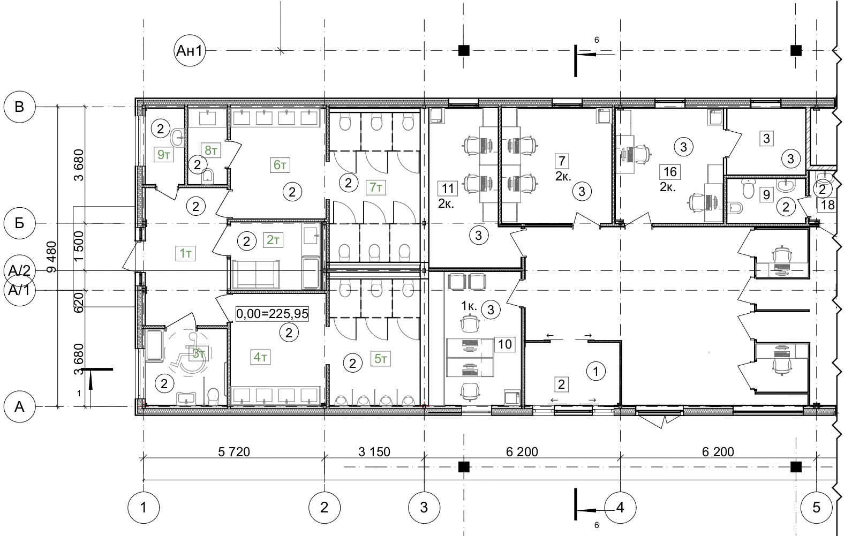
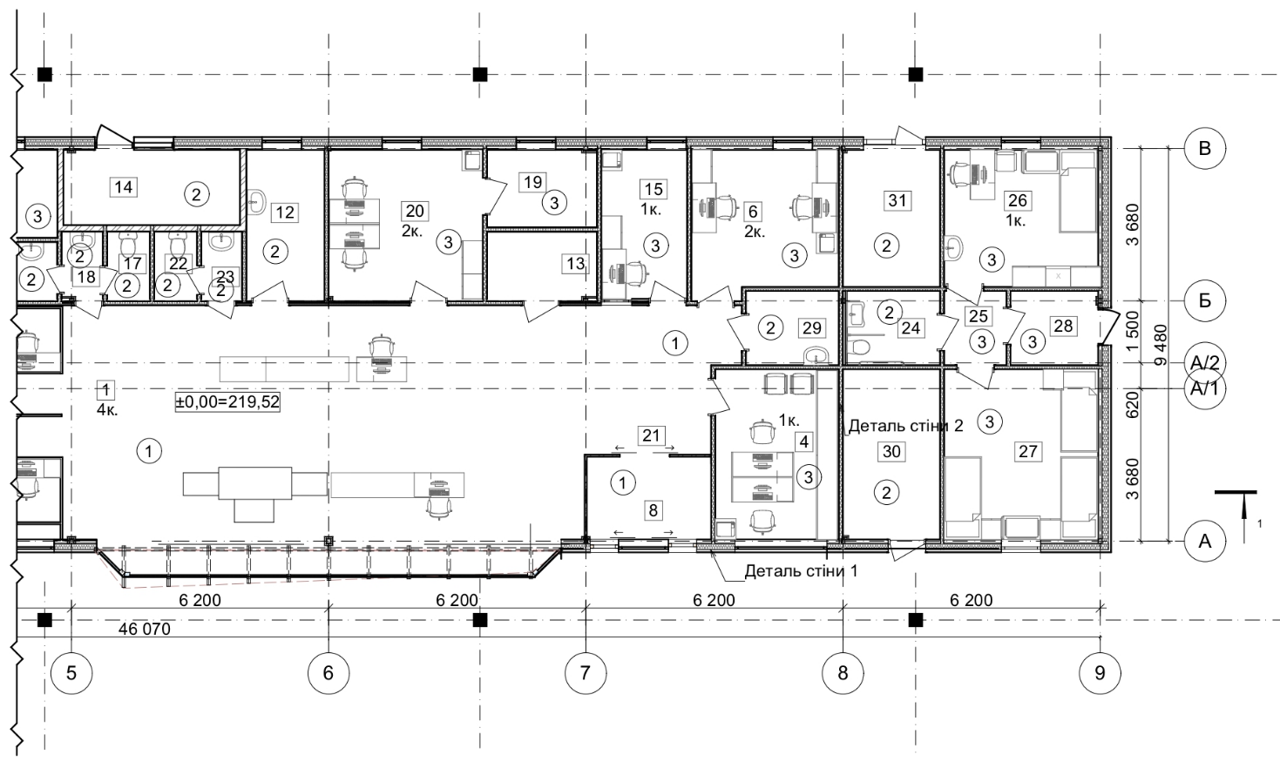
Explanation of premises
No. | Name | Area m²
1 | an inspection room for passport and customs control | 115,86
2 | Vestibule | 6,02
3 | Premises of the switching border service | 5,29
4 | Office of the customs service shift supervisor | 12,29
6 | Office premises of the customs service | 12,30
7 | Office premises of the border service | 12,76
8 | Vestibule | 6,00
9 | Premises for women's personal hygiene | 3,56
10 | Office of the border guard service shift supervisor | 12,40
11 | Office premises of the border service | 12,16
12 | Premise for personal inspection with a washbasin | 6,87
13 | Premises for placement of technical means of customs control | 4,43
14 | boiler room | 7,70
15 | Bank premises | 7,45
16 | premise for placement of technical means for border control | 12,50
17 | public toilets | 1,72
18 | Vestibule - sluice | 1,66
19 | Premises of the switching customs service | 4,95
20 | Office premises of the customs service | 13,37
21 | Corridor | 12,28
22 | public toilets | 1,72
23 | Vestibule - sluice | 1,66
24 | universal sanitary and hygienic room for a group of citizens with limited mobility | 4,00
25 | Corridor | 2,68
26 | Doctor's office | 12,28
27 | Insulator | 15,27
28 | Vestibule | 3,79
29 | Room for cleaning supplies | 4,00
30 | switchboard room | 9,63
31 | metering station | 7,74

1т | Vestibule | 11,23
2т | mother and child's room | 6,05
3т | universal sanitary and hygienic room for a group of citizens with limited mobility | 6,22
4т | Vestibule - sluice men's toilet | 10,62
5т | Men's toilet | 11,76
6т | Vestibule -sluice women's toilet | 10,52
7т | Women's toilet | 13,99
8т | A woman's personal hygiene room | 2,98
9т | Pantry for cleaning supplies | 2,99

Service building at the exit from Ukraine 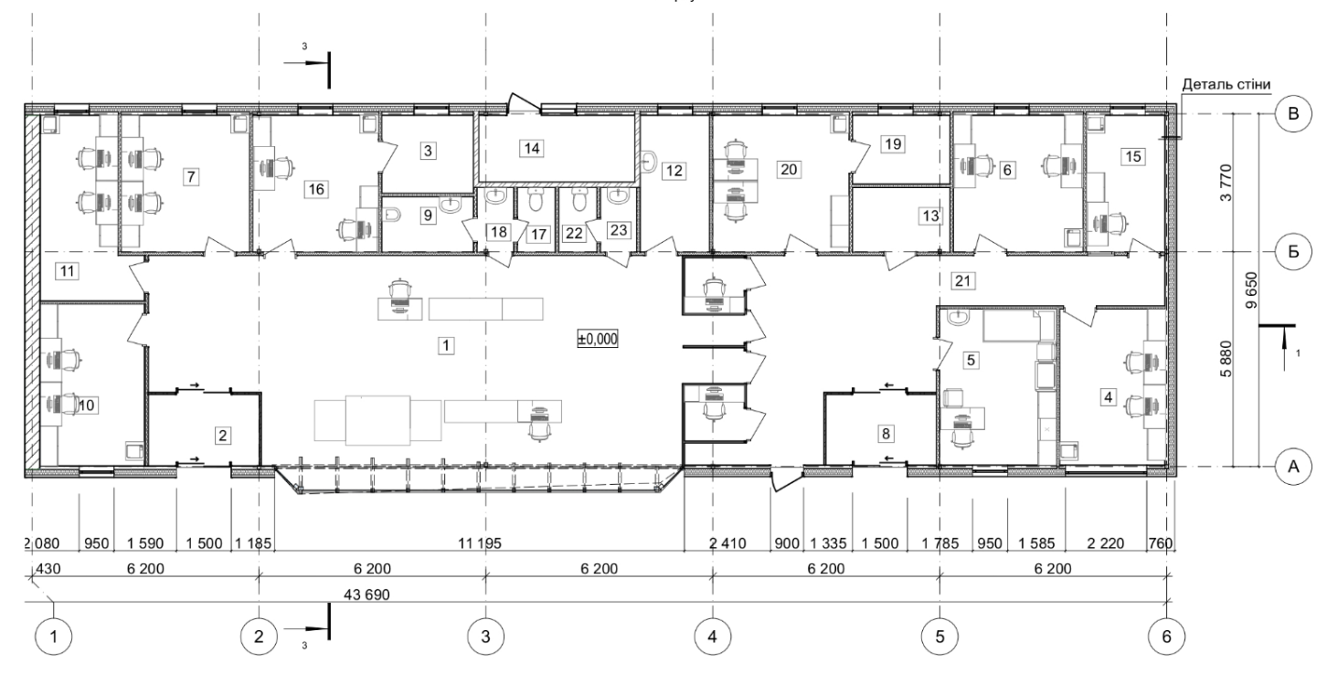
Explanation of premises
No. | Name | Area m²
1 | an inspection room for passport and customs control | 118,30
2 | Vestibule | 5,90
3 | Premises of the switching border service | 5,33
4 | Office of the customs service shift supervisor | 12,35
5 | Premises of the medical center | 13,51
6 | Office premises of the customs service | 13,26
7 | Office premises of the border service | 13,12
8 | Vestibule | 5,83
9 | Premises for women's personal hygiene | 3,73
10 | Office of the border guard service shift supervisor | 12,96
11 | Office premises of the border service | 12,05
12 | Premise for personal inspection with a washbasin | 7,15
13 | Premises for placement of technical means of customs control | 4,65
14 | Boiler room | 7,78
15 | Bank premises | 8,10
16 | Premise for placement of technical means for border control | 12,81
17 | Public toilets | 1,80
18 | Vestibule - sluice | 1,74
19 | Premises of the switching customs service | 5,00
20 | Office premises of the customs service | 13,85
21 | Corridor | 8,50
22 | toilet | 1,81
23 | Vestibule - sluice | 1,72

Box for in-depth inspection of motor vehicles at the exit from Ukraine

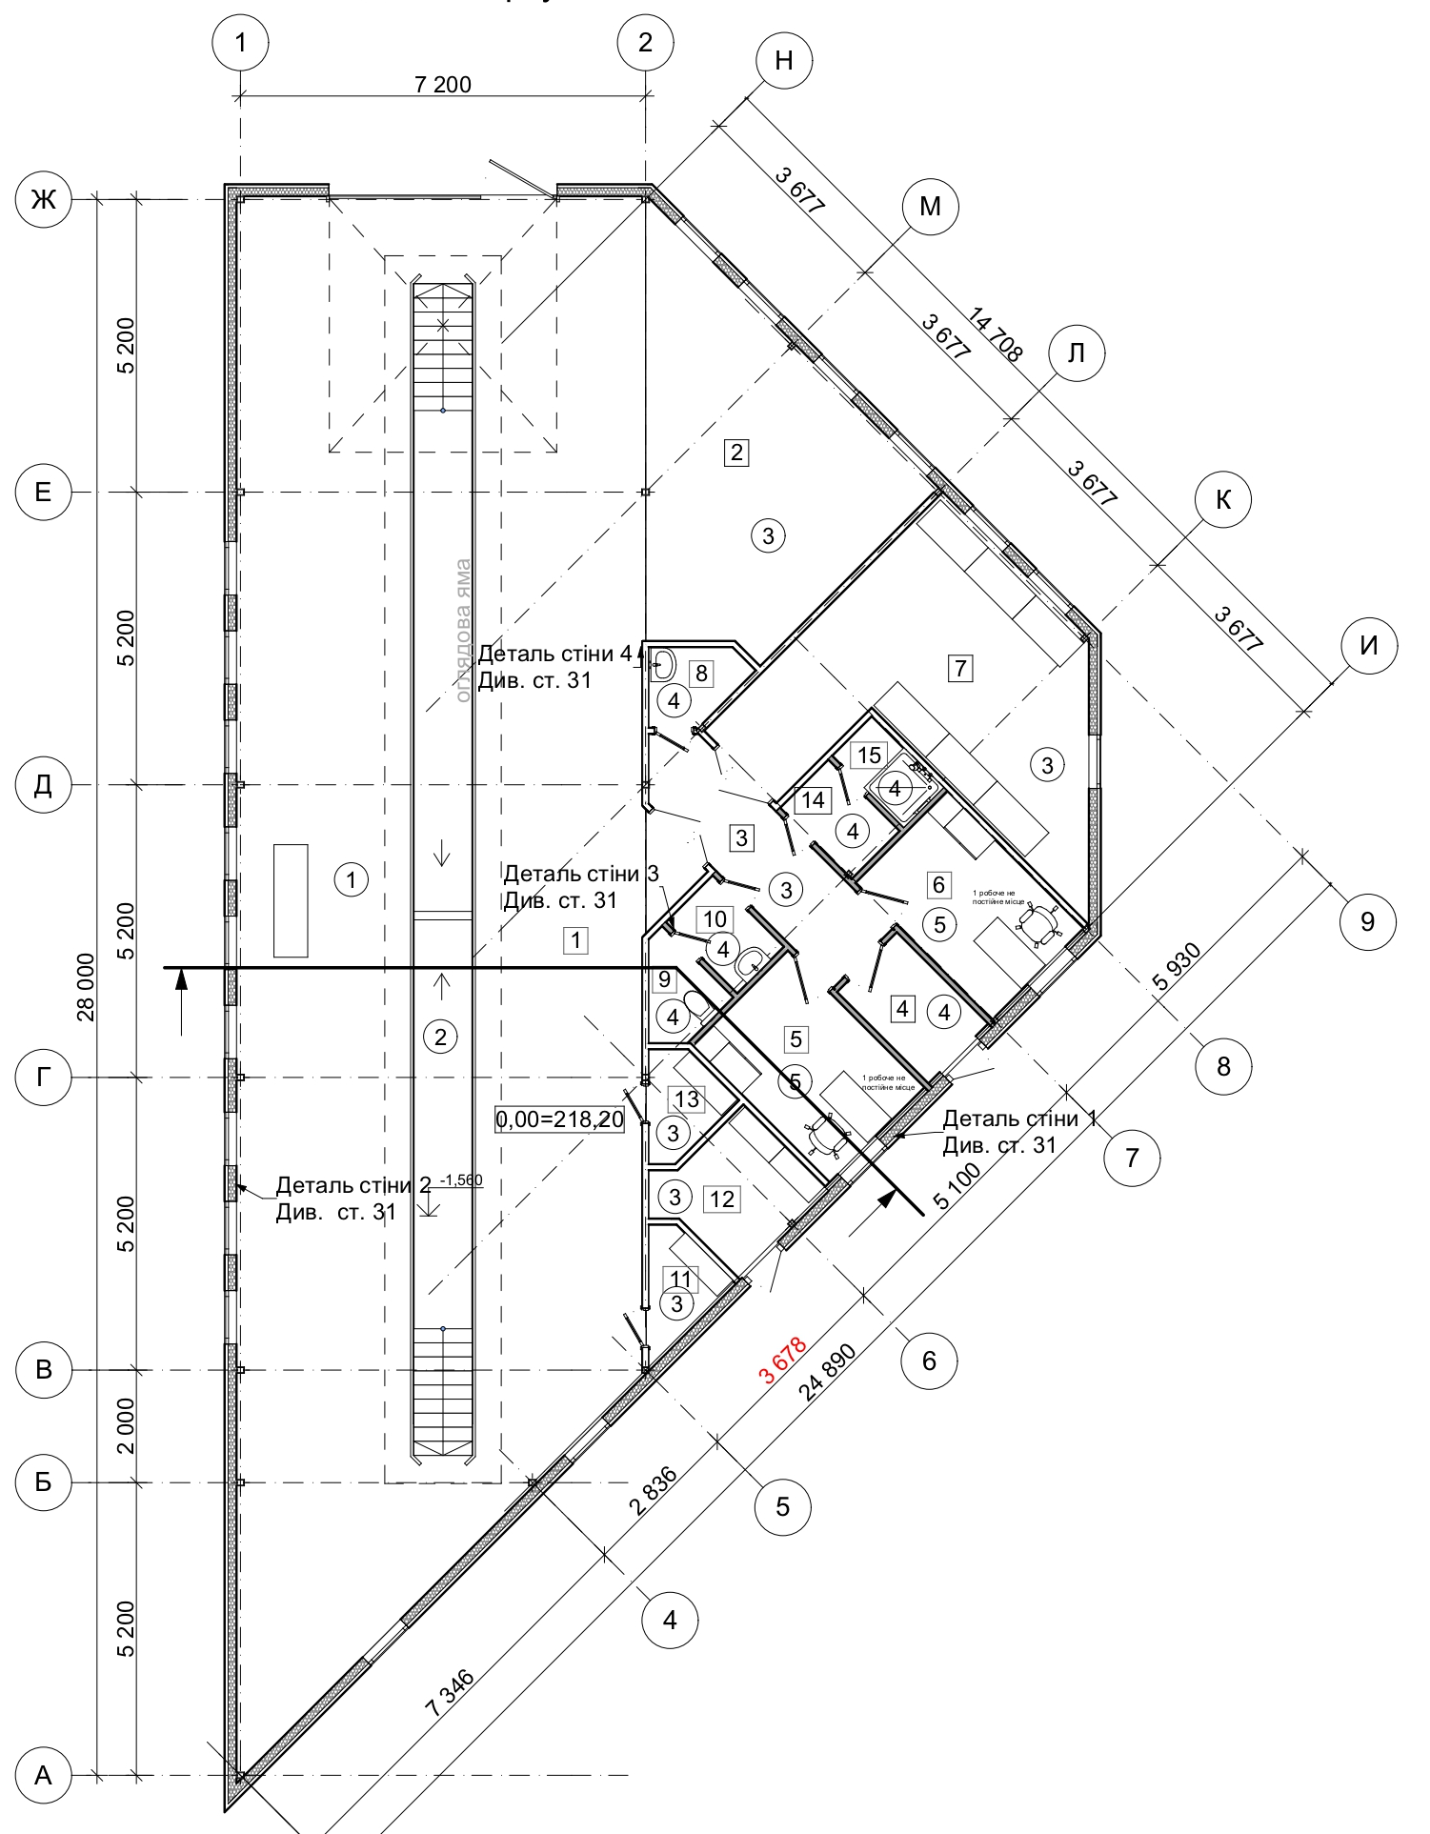

Explanation of premises
№ | Name | Area m²
1 | Box premise for inspecting buses | 176,63
2 | Premises for tire mounting equipment | 24,12
3 | Corridor | 7,73
4 | Vestibule | 3,45
5 | Border guard service personnel premise | 8,19
6 | customs service personnel premise | 7,93
7 | Temporary storage of confiscated goods | 24,03
8 | Premises of cleaning equipment | 2,19
9 | Toilet facility | 2,03
10 | Toilet facility | 2,12
11 | Premises for storing tools | 2,18
12 | switch room | 4,95
13 | Premises for storing tools | 2,33
14 | Sluice | 2,17
15 | Shower room | 1,80
 |  | 271,85 м²

Box for in-depth inspection of motor vehicles at the entrance

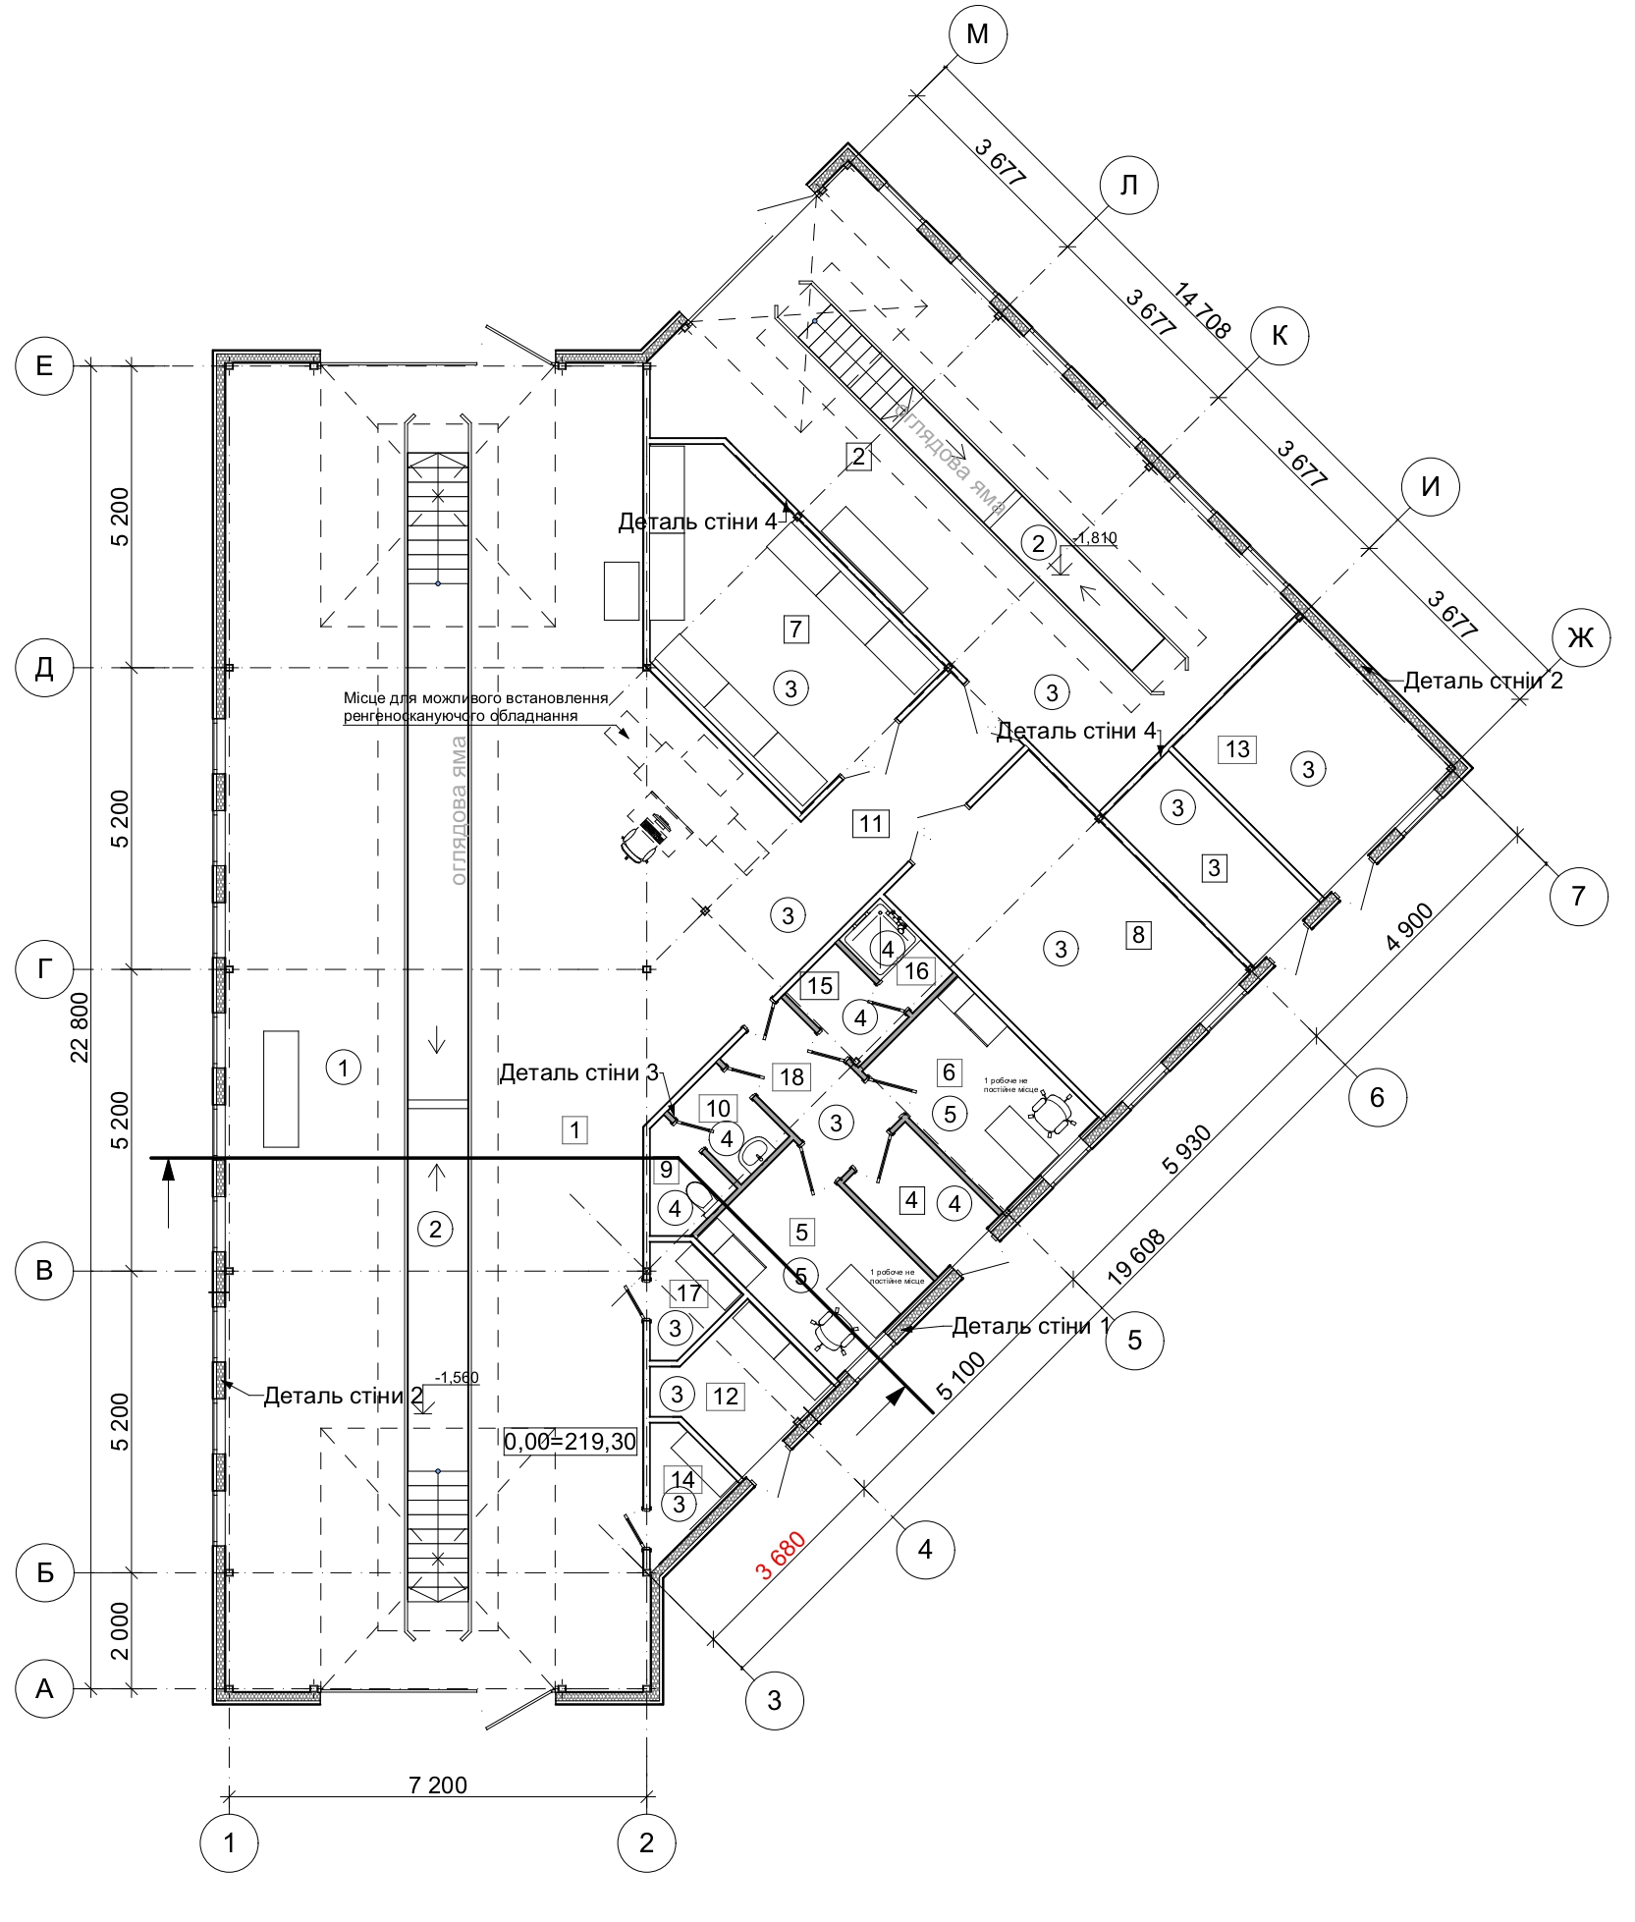

Explanation of premises

№ | Name | Area m²
1 | Box premise for inspecting buses | 173,32
2 | Box premise for inspection of minibuses and passenger cars | 54,68
3 | Compressor room | 5,77
4 | Vestibule | 3,46
5 | Border guard service personnel premise | 8,27
6 | customs service personnel premise | 8,06
7 | Temporary storage of confiscated goods | 18,78
8 | Premises for tire mounting equipment | 18,90
9 | Toilet facilities | 1,98
10 | Toilet facilities | 2,12
11 | Corridor | 15,10
12 | switch room | 5,02
13 | Boiler room | 11,32
14 | Premises for storing tools | 2,19
15 | Sluice | 2,17
16 | Shower room | 1,80
17 | Premises for storing tools | 2,26
18 | Corridor | 4,36
 |  | 339,56 м²

Pavilion for passport and customs control, Checkpoint and checkpoint dispatcher pavilion
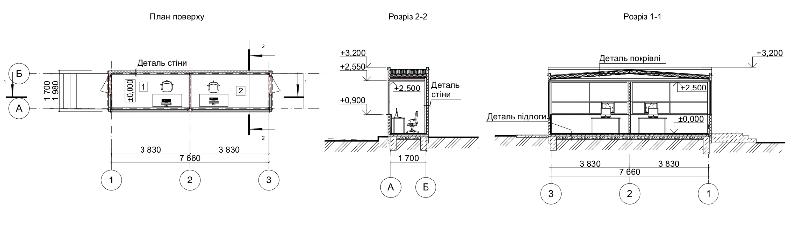
Explanation of premises

No. | Name | Area m²
1 | Premises of customs control | 6,00
2 | Passport control room | 6,00

checkpoint pavilions

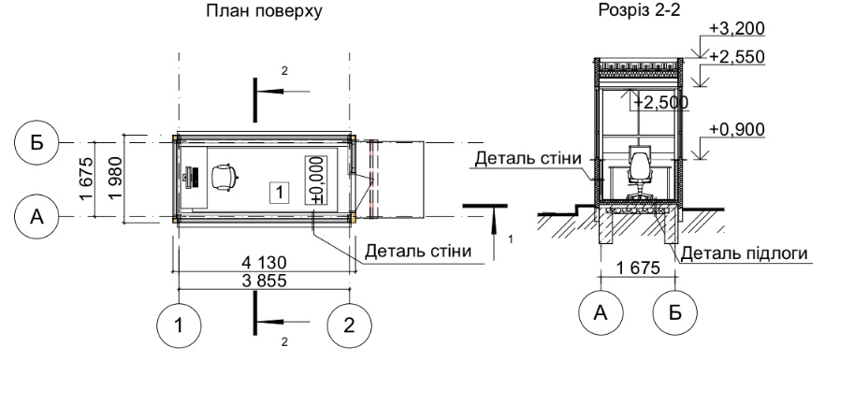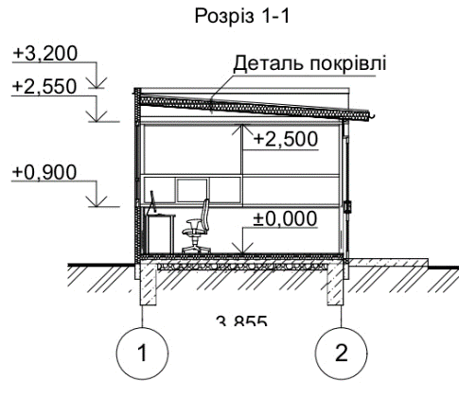

Explanation of premises

No. | Name | Area m²
1 | Service premises | 6,07
 |  | 6,07 м²

Public toilets at the exit from Ukraine
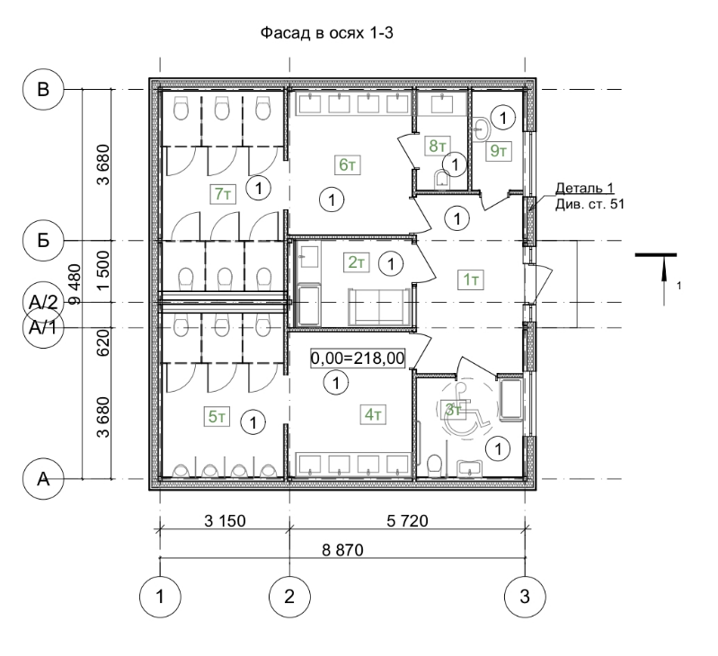
Explanation of premises
No. | Name | Area m²
1т | Vestibule | 11,23
2т | mother and child's room | 6,05
3т | universal sanitary and hygienic room for a group of citizens with limited mobility | 6,22
4т | Vestibule - sluice men's toilet | 10,62
5т | Men's toilet | 11,76
6т | Vestibule -sluice women's toilet | 10,52
7т | Women's toilet | 13,99
8т | A woman's personal hygiene room | 2,98
9т | Pantry for cleaning supplies | 2,99

Перспективний вигляд (візуалізація)
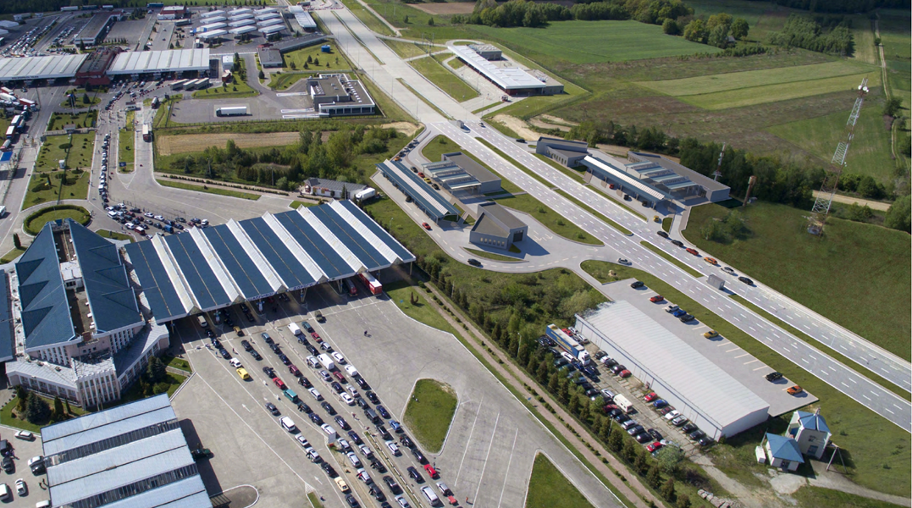
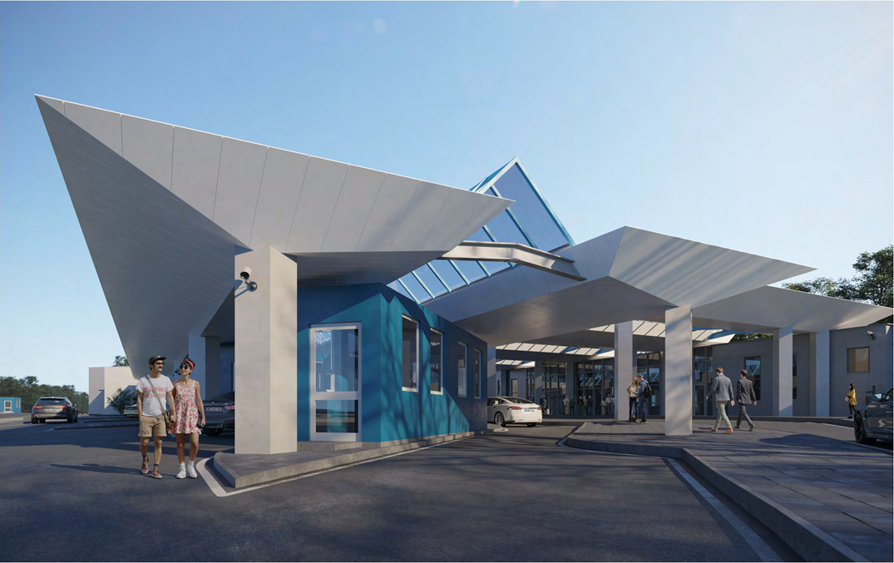

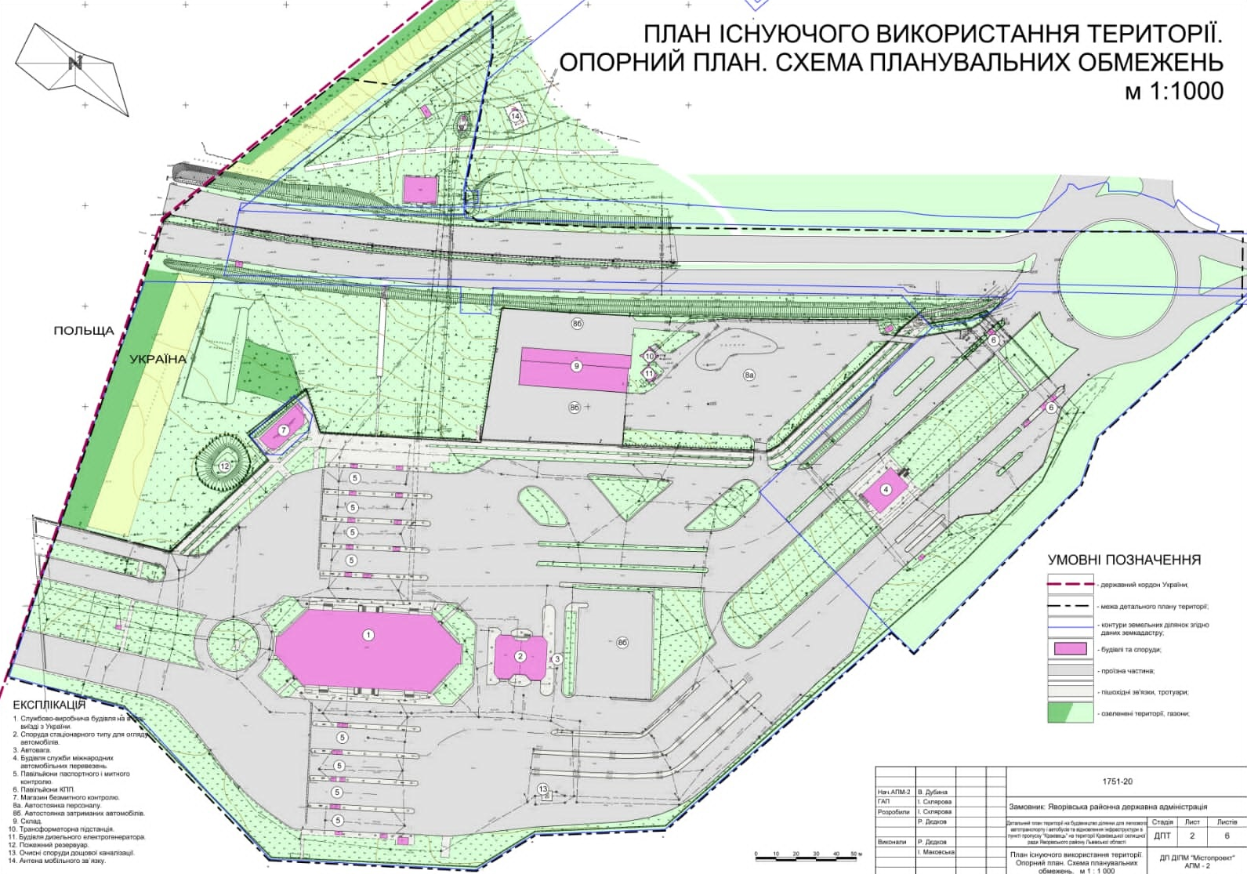

The plan for organizing the movement of cargo vehicles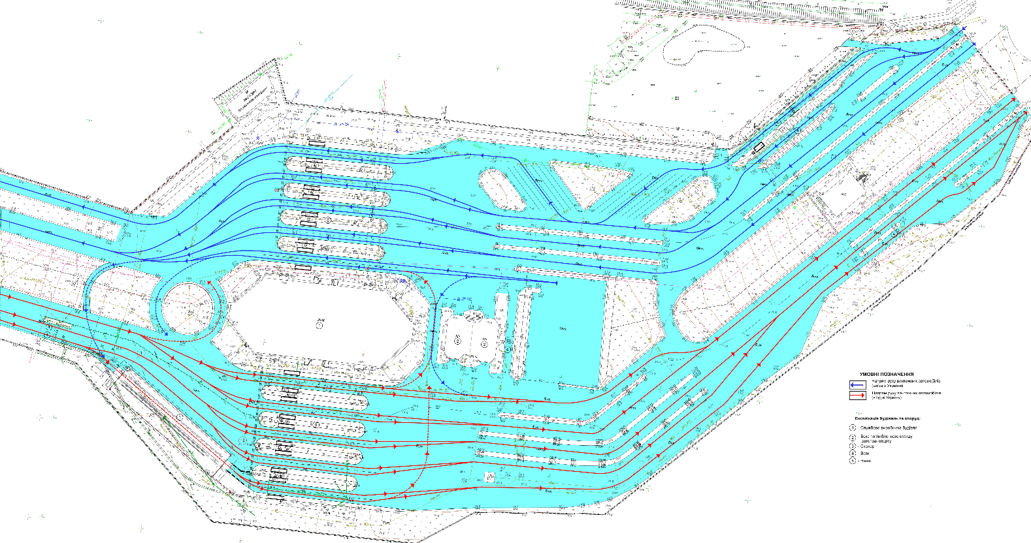

Scheme of the master plan for Construction of area for passenger vehicles and buses in the checkpoint for road traffic “Krakivets”

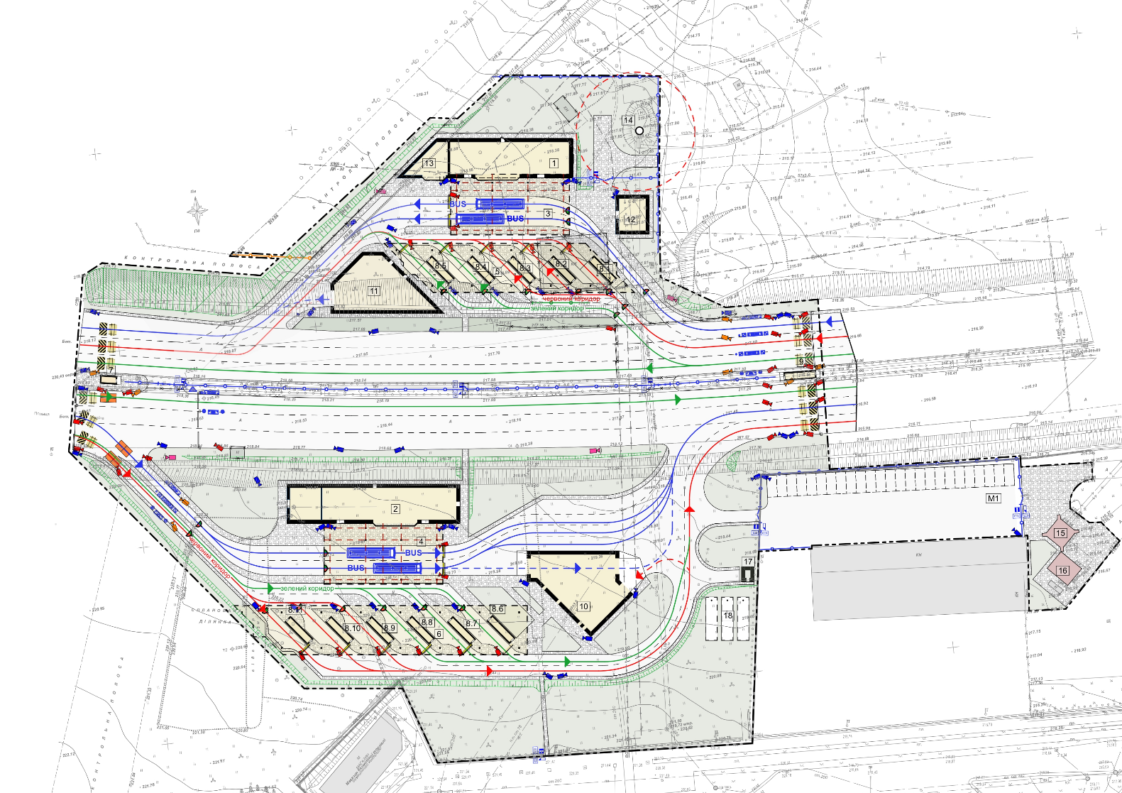

Explanation of premises
No. | Name | Area m²
1 | Service building at the exit from Ukraine
2 | Service building at the entrance with public toilets
3 | Sheds over customs and passport control zones buses at the exit from Ukraine
4 | Sheds over customs and passport control zones buses at the entrance to Ukraine
5 | Sheds over customs and passport control zones at the exit from Ukraine
6 | Sheds over customs and passport control zones at the entrance to Ukraine
7 | checkpoint pavilions
8.1 | Pavilion for passport and customs control
8.2 | Pavilion for passport and customs control
8.3 | Pavilion for passport and customs control
8.4 | Pavilion for passport and customs control
8.5 | Pavilion for passport and customs control
8.6 | Pavilion for passport and customs control
8.7 | Pavilion for passport and customs control
8.8 | Pavilion for passport and customs control
8.9 | Pavilion for passport and customs control
8.10 | Pavilion for passport and customs control
8.11 | Pavilion for passport and customs control
9 | Checkpoint and checkpoint dispatcher pavilion
10 | Box for in-depth inspection of motor vehicles at the entrance to Ukraine
11 | Box for in-depth inspection of motor vehicles at the exit from Ukraine
12 | Public toilets at the exit from Ukraine
14 | Water tower
15 | Transformer substation
16 | Diesel generator building
17 | Fire pumping station
18 | Fire tanks

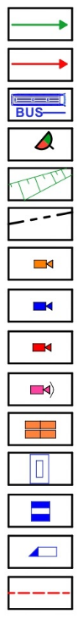
- Designed buildings and structures
- Existing buildings and structures to be dismantled
- Existing buildings that are not included in the scope of work
- Road surface
- Paving with concrete paving stones
- Lawn
- Designed turnstiles
- Existing fence
- Projected fence
- Goal
- wickets
- Barrier
- Racks of radiation control
- Addition of primus dryness reduction
- Overhead road blocker
- Anti-ram blocker

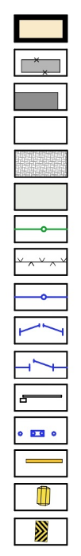
- direction of movement of cars (green corridor)
- direction of movement of cars (Red corridor)
- Bus direction
- Traffic lights
- slopes
- boundaries of landscaping
- Surveillance camera of border guards
- External surveillance camera
- Number recognition camera
- The camera is rotatable and controlled externally
- Car barrier of the carpet type 1mx2m
- Card reader
- Magnetic contact detector
- Electromagnetic lock
- Zone

